Behaviour Policy

Isleham Church of England Primary School

March 2021

1.Introduction
Our school is a community of pupils, teachers, teaching assistants, staff, governors,
parents/carers and other adults. A community works best where there is mutual respect between all
members and an agreed code of conduct within which all activities take place. It is our aim to ensure that every member of our school community feels valued and respected, and that each person is treated fairly and well, having equal opportunity to learn. We believe in equity as shown in the image below.
Table 1.1 Equality v. Equity (Cambridgeshire Steps, 2019)
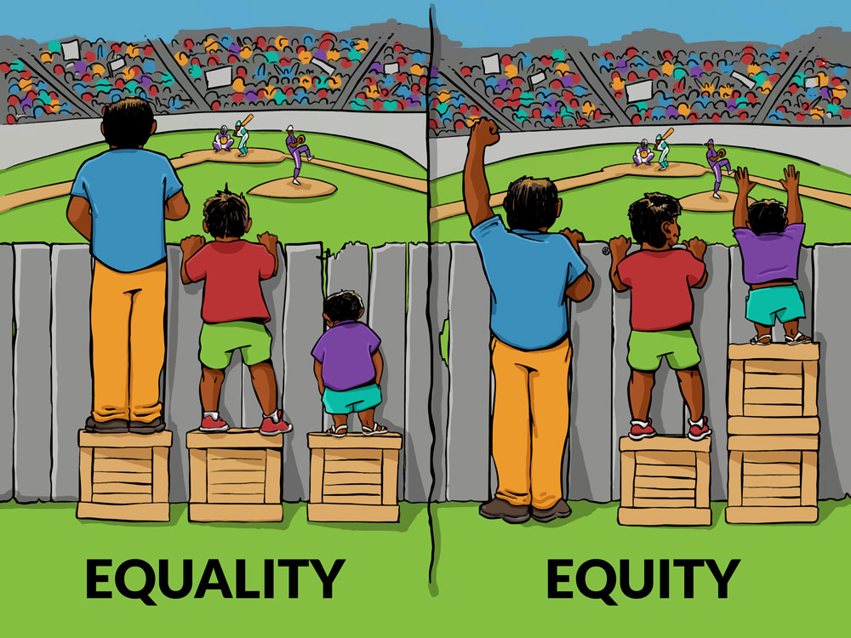

We believe it is essential to provide the support each child needs to thrive. We are a caring community, whose values are built upon mutual trust and respect for all.

This positive behaviour policy is designed to support the way in which all members of the school live and work together effectively.

2. What are the principles or ethos that underpins the promotion of effective behaviours for learning at Isleham Church of England Primary School?
The school follows and teaches the following Christian Values for life:-
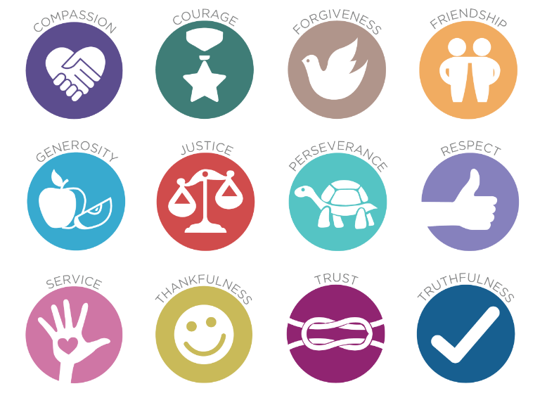
Table 2.1: Christian values by ‘Imaginor’ as adopted by Isleham Primary School, 2016

The school follows the Cambridgeshire STEPs (Step-On) programme, for which all staff are trained annually- “The process of taking necessary steps to ensure that every young person is given an equality of opportunity to develop socially, to learn and to enjoy community life.” (Cambridgeshire STEPs December 2019). We promote a therapeutic approach to behaviour management, prioritising pro-social experiences, feelings and behaviours in our pupils in school (‘the roots which lead to the desired fruits’) yet recognising that for some pupils who have experienced more antisocial experiences than others in their lives, more support may be required to behave pro-socially in school.

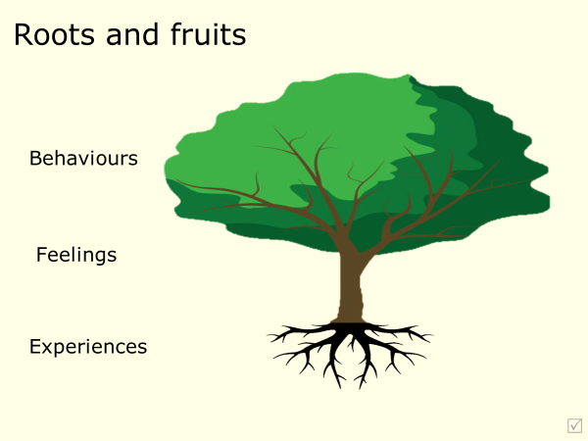
Table 2.2: Roots and fruits

3. What are the purpose and aims of the policy?
At Isleham Primary School we aim:
- to recognise, promote and reward positive behaviour.
- to work in partnership with parents and carers to support the social and academic development of all pupils.
- to provide a framework to support and promote socially acceptable behaviour.
- to promote an environment where Christian values are respected and followed
- to ensure staff focus on de-escalation and preventative strategies rather than focusing solely on reactive strategies.
- to ensure staff know how to manage difficult or dangerous behaviour, and to have an understanding of what challenging behaviour might be communicating.
- to ensure that all members of the school community ensure that they promote the school vision
- to focus and plan to manage stable behaviour (the pro-social behaviours that any individual is capable of displaying) and to recognise, plan and respond to escalating behaviours in order to prevent harmful behaviour. “Key phrase -CATCH THEM GETTING IT RIGHT” (Cambridgeshire STEPs)

4. What are the school’s expectations of behaviour?
- we speak and listen to each other politely.
- we show acceptance and respect each other’s right to be different.
- we treat each other with respect at all times.
- we promote good behaviour and self/internal discipline.
- we promote behaviour that prevents bullying.
- we promote behaviour to ensure that all children are able to complete their learning.
- we promote behaviour which helps regulate the conduct of other children.
- we promote an environment where no one deliberately sets out to make another person feel uncomfortable or unhappy.

5. What are the school rules?
To support all in our school community, everyone follows a set of golden rules.

ISLEHAM’S GOLDEN RULES

BE SAFE
BE RESPECTFUL
TRY YOUR BEST

Our expectations are also set out in the home-school agreement published annually. In addition, at the start of each school year, the class teacher will discuss with the children the values, routines and rules within the classroom. They will be agreed, displayed and referred to regularly.

6. Examples of behaviours encompassed by the school rules:
Be safe | Be Respectful | Try your best
-caring for others  -using equipment as shown and in line with its purpose  -recognising early warning signs in self and others  - seeking help and support  - avoiding putting self and others at risk | -following instructions  -listening carefully  -working collaboratively  -asking questions or challenging others politely  -demonstrating equity and fairness  -looking after the learning environment and resources  -demonstrating acceptance of others  -employing a calm manner  -having patience | -resources organised  -completing work with pride and care  -completing reading and home learning  -listening attentively  -being engaged  -being open-minded – ready to make an effort  -persevering
Above and beyond
-awareness of the safety of others  -setting an example to others  -acting upon concerns | - showing empathy  - listening to others’ points of view | -positive mindset  -challenging yourself - having an enquiring mind  -preparing for others or supporting them  -using your initiative

7. How will positive behaviour be promoted?
The promotion of positive behaviours for learning is central to our school behaviour policy. We have a clear system of rewarding positive behaviour as follows:
- All members of the school community are encouraged to praise and congratulate each other. This may involve a small sticker or smiley face on work, or an approving look, words of praise or smile to show recognition of a child doing the right thing’- staff aim to spot children ‘getting it right’.
- Any member of the school community can also put forward a child for a ‘Special Mention’ to the Headteacher- they will receive a golden sticker and mention in the school’s “Golden Book”- examples of reasons for ‘special mention’ include excellent behaviour, attitude or hard work has really stood out in a particular event that week
- Values and behaviour are reported upon to parents/carers at least termly in pupil’s verbal and written school reports, or during parent consultations.
- Support of parents/carers and pupils is secured through display and communication of expectations and the use of a home-school agreement
- The school acknowledges the efforts and achievements of all children, both in and out of school, through its weekly newsletters and web pages.

As part of their personal and social development the children will also participate in ‘circle time’/ ‘discussion time’. This time is devoted to enhancing self-esteem, self-discipline and positive relationships through planned age-appropriate structured class discussions. Children also participate in PSHE classes linked with circle time. These approaches benefit children as individuals and as members of the school family and provide an opportunity for children to share pleasures, worries, and fears and help them to learn to take turns and listen to others.

Our school staff will:
- meet and greet learners and parents positively
- recognise, reward and acknowledge expected and ‘above and beyond’ behaviours throughout every lesson and beyond the classroom
- reinforce and refer to ‘Be safe, Be respectful, Try your best’ golden rules
- be calm and allow ‘take up time’ when redirecting behaviours that do not meet expectations
- personally follow up on incidents every time, retain ownership and engage in reflective dialogue in a safe space for all parties
- never ignore behaviours which fall short of expectations

Every day school leaders will (in addition to the above):
- when required, stand alongside colleagues to support, guide and model adherence to this policy
- be a regular visible presence around school praising positive behaviours especially during transition times
- share good practice and celebrate success
- regularly review provision for community members who require support beyond the scope of this policy in time of crisis or need
- ensure staff training and mentoring is provided when required
- encourage adults and learners to take responsibility for reparations
Immediate ways to recognise behaviour that is ‘above and beyond’ expectations:
- Verbal recognition ‘Wow, thank you for doing …, it was above and beyond my expectations.’
- Awarding a sticker or smiley face
- Putting forward child for special mention and note home to parents via ClassDojo
8. Responding when behaviours fall below expected levels (low level disruption):
We recognise that all children may occasionally need reminders about how to behave in a positive way.

Our behaviour response aims to understand why any antisocial behaviour is happening and give children multiple opportunities to reflect upon, repair and restore any situation where school rules have been broken, in dialogue with an adult and others in the group if needed.

Stage | Action | Example Script
Reminder | A reminder of the rule, delivered to the whole class, or privately (wherever possible) if specific to one child | “Remember…’  “Great to see you listening/ working hard over here… Let’s see everyone ready’  “I’ve seen you sitting beautifully so many times, can you show me now?”
Redirection | gentle encouragement to conform, a small kind comment, a nudge in the right direction, a non-verbal cue, a private chat, or a ‘change of scenery/ focus’ to move to expected behaviour | “Let’s go over here/ do this…”  “Super listening/ great start- what will you do next…?”  Check in privately, ‘Can I help you with…?’  “What do you need to make you successful?”
Caution | A clear verbal caution delivered privately wherever possible –an opportunity to re-engage and highlighting need for ‘thinking time’ if no change.  NB walk and talk is an option if stressors are already in play | ‘I need to see you…in next x minutes.’  “Shall we…. Or….?”  “I need….” First…. Then…..  “Thank you for …’  “Can you get on now or do you need some time in the thinking space?”  Congratulation for good choices
Thinking time  5 minutes maximum in safe space (with timer if appropriate) | A chance to reflect away from others- offering a positive choice to engage. | ‘I can see you are finding this difficult- it would be a good idea to have a thinking space away from the others – indicate space’  ‘Take 5 minutes, and then come back in when you’re ready to join back in …  I will leave you to make a choice about joining in now or finishing off at lunchtime.”
Restoration  (completion of ‘reflect, repair, restore’ grid) | A restorative meeting should take place before the next session if ‘Thinking time’ has been needed. | “Thank you for talking to me ”  “How were you feeling?”  “How did … make people feel?”  “How do you feel now?”  ‘What do you think we should do to put things right/ avoid this happening again?’  “I am glad we have  found a way to move forward.’
Formal Meeting  (THIS STAGE IS UNLIKELY TO BE REACHED FOR LOW LEVEL DISRUPTION) | A meeting with a senior leader, the child, the original member of staff dealing with the issue (and the class teacher when possible) This is recorded onto the school Provision Map system and results in agreed targets.  This will be fed back to parents in the form of a note to advise of targets set and to invite further discussion. | Reviewing the ‘reflect, repair, restore’ grid and talking through agreed processes to avoid a recurrence.
NB A formal meeting will only take place for repeated low-level disruption.
After speaking to children about low level disruption, school staff will step away and give multiple opportunities for the child to re-engage.
A short restoration meeting should take place after any ‘Thinking time’.
This is to repair trust and reaffirm the relationship between staff members and children.

Steps and scripts for responding when behaviours fall far below expected levels (more serious incidents):
Stage | Action | Example script
Thinking time and Restoration  (completion of ‘reflect, repair, restore’ grid) | A restorative meeting should take place at the earliest opportunity (after thinking time of up to 15 minutes, if needed for a child to calm sufficiently to be able to talk) if a serious incident has occurred.  The victim(s) may need to be involved in any additional dialogue to make reparations and discuss feelings more readily. | “Take a seat here just to calm for a moment, and I’ll be here- come and let me know when you want to talk through what’s happened”  “Thank you for talking to me.”  “Can you tell me how this started?”  “How were you feeling?”  “How did … make people feel?”  “How do you feel now?”  ‘What do you think we should do to put things right/ avoid this happening again?’
Consequence  A senior leader may support with the ‘reflect, repair, restore’  discussion or another member of staff who has a pre-existing good relationship with the child | NB a ‘time out’ for emotions to reset may be required before instigating a consequence.  POSSIBLE CONSEQUENCES INCLUDE:  Missing time with peers if behaviour has been unsafe or disrespectful  Making realistic reparations to the victim(s) (see section 9) | “I am concerned that you have not been safe/ respectful…”  “There is a consequence for …….”  “Do you understand why I have decided this?  “Is there anything else you think we should do to make things right or avoid this happening again?”  “Thank you for talking to me”
NB elements of the Restoration Script may be useful for reflections in the consequence stage
Formal Meeting | A meeting with a senior leader, the learner, the original member of staff dealing with the issue and the class teacher which is recorded on ‘Provision Map’ for the child and results in agreed targets.  This will be fed back to parents via a phone call to advise of targets set and any actions required. | Reviewing the ‘reflect, repair, restore’ grid and talking through agreed processes to avoid a recurrence.

9. Examples of Possible Consequences:

Educational Consequences | Protective Consequences
Completing tasks.  Rehearsing.  Assisting with repairs.  Educational opportunities.  Research.  Restorative meeting. | Isolation/removal from an area temporarily.  Increased staff ratio.  Separate access to outside space for a set period of time  Escorted in social situations.  Differentiated teaching space.  Removal from classroom.

10. De-escalating body language
Staff will use de-escalating body language in school to support dialogue
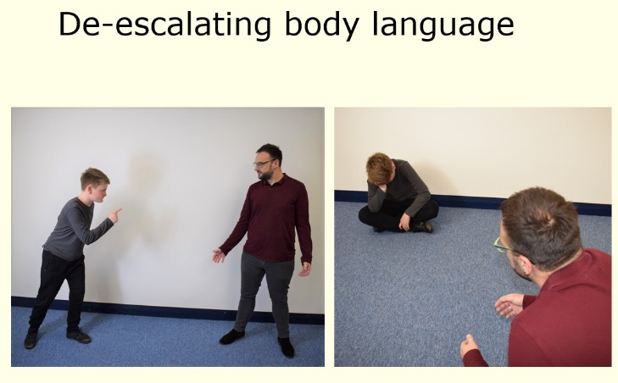
- Outside of an outstretched arm
- Good distance
- Standing to the side
- Relaxed hands
- Managing height
(Cambridgeshire Steps, 2019)

11. What about children with diagnosed behavioural difficulties or specific needs?
Children who have diagnosed behavioural difficulties or specific needs (E.g. ADHD, ASD) may require an adjustment in this policy following a discussion with the Headteacher, SENCo, Outside Agencies and parents/carers in order to best meet the child’s individual specific needs and to support their well-being. In this instance, a behavioural plan will be drawn up clearly indicating the ways in which the child will be responded to when their behaviours are impacting on their own or others’ learning.

12. What items are banned in school?
If banned items are brought to school, be that intentionally or by unintentionally, the Headteacher (or Deputy Headteacher in her absence) will refer to Step 4-7 of the response charts. Prohibited items are defined in the Education Act 1996 and the Schools Regulation 2012 as:
- Knives or weapons, alcohol, illegal drugs and stolen items.
- Tobacco and cigarette papers, fireworks and pornographic images.
- Any articles that the member of staff reasonably suspect has been, or is likely to be, used to
commit an offence, or to cause personal injury to, or damage to property.
13. What happens if a child makes malicious allegations against school staff or other children?
Pupils that are found to have made malicious allegations will have breached the aims and expectations of behaviour listed in this policy. School staff will seek to discuss the issue with the child and his/her parents, including or seeking advice from the police if there are grounds for believing a criminal offence may have been committed.

14. Physical intervention/ positive handling in the primary school
At Isleham Primary School, we are committed to ensuring all of our children are treated with care and respect- in line with the school’s Safe Touch policy, a child would and should only be physically ‘handled or restrained’ in accordance with the latest guidance by the DfE, by an adult in school in order to:
• prevent him/her from committing a criminal offence.
• prevent him/her from harming themselves or others (including physical and mental).
• prevent or stop him/her from causing serious damage to property.
Planned physical intervention in cases of extreme need should be:
• Agreed in advance by a team in consultation with the child and his or her parents/ carers.
• Planned in advance including broader strategies for addressing the child’s behavioural difficulties.
• Under the supervision of an identified member of staff.
• Subject to recording, reporting, monitoring and, if necessary, investigation.
Members of staff receive regular additional training through the Cambridgeshire STEPS programme about physical handling of pupils, at least annually. The training covers a range of areas, including conflict de-escalation, calm body language, debriefing opportunities for children following any anti-social behaviours and positive handling techniques. School staff will always follow this training and the schools’ ‘Safe Touch’ policy and parents are always fully informed about any situation that has arisen involving their child.
15. Physical contact permitted and agreed in our school
There are occasions however when we consider it completely natural and acceptable for some physical contact to occur between staff and children for a variety of reasons, for example:
• to comfort or congratulate a child
• to direct or steer a child
• for activity reasons (for example in drama, physical games, some musical instrument tuition)
Please see the school’s current Safe Touch Policy for further details of techniques used.

16. What does exclusion mean?
We do not wish to exclude any child from school but where there is sufficient evidence that
a pupil has committed a disciplinary offence/ serious misbehaviour (and allowing the pupil to remain in school would seriously harm the education or welfare of the pupil or others in the school), the pupil may be excluded from attending school for a fixed period or permanently. We use the current Cambridgeshire County Exclusions guidance which can be found on the cambslearntogether.co.uk website, to ensure that children, parents and staff understand the steps in this process.

Only the Headteacher, Deputy Headteacher or the senior leader in charge in the Head’s absence, has the power to exclude a pupil. Whilst not an exhaustive list, the following sets out the kind of serious misbehaviour that might lead to exclusion:-
    - physical assault including violent behaviour causing harm to others
    - sexual misconduct
    - drug and alcohol related incidents
    - damage to property
    - theft
Permanent exclusion will normally only be used as a last resort when all other reasonable strategies have been exhausted without success. However, some offences will be deemed so serious or affect the discipline and well-being of the whole school community that permanent exclusion for a first or one-off offence will be deemed by the Headteacher to be an appropriate response. These types of very serious behaviour include:
    - serious violence against another pupil or member of staff
    - sexual abuse or assault
    - supplying an illegal drug
    - carrying, threatening to use, or using an offensive weapon.

If the Headteacher excludes a child, they will inform the parents or carers within the prescribed timescales, using the agreed County guidelines, giving reasons for the exclusion. At the same time, the Headteacher will make it clear to the parents or carers that they can, if they wish, make representation or appeal against the decision to the governing body. The school will inform the parents or carers how to make such an appeal.
17. What about bullying?
In the rare cases where children may be repeatedly unkind to others, we aim to act promptly to avoid any further repetition. If we discover that acts of bullying or an act of intimidation has taken place, the Headteacher will be informed, the incident will be logged and parents/carers will be notified. While it is very difficult to eradicate bullying, we will do everything in our power to ensure that all children attend school free from fear. Please refer to the school’s current Anti-bullying policy.

18. Behaviour outside school
The school expects pupils to behave in a positive way at all times, including offsite and outside usual school hours whether or not they are under the direct supervision of school staff e.g. on a school trip/ at an evening school event such as a PTA disco. Whilst it would be rare for a child to receive a consequence in school-time for behaviour outside school hours, parents are asked to support the school in ensuring any antisocial behaviour does not go unchecked, and that children behave pro-socially both within school and within the local community.
19. Confiscation
The school may confiscate items such as mobile phones and sharp objects in certain circumstances. Appropriate arrangements for the return of these items will be made. If it was necessary, and in the interests of the health and safety of the pupils and staff, screening and searching of pupils for weapons will be conducted according to the 2014 Searching, screening and confiscation advice.
20. What are Outside Agencies?
- Cambridgeshire STEPs team
- SEN Specialist Teaching team
- Educational Psychology and Specialist Support
- Cambridgeshire County Council
21. What support is there for parents/carers?
- Early Intervention Family Support worker- Emily Norman
- Cambridgeshire STEPs team
- Cambridgeshire County Council

22. How will this policy be monitored?
The Headteacher monitors the effectiveness of this policy on a regular basis (at least annually) and reports to the governing body on the effectiveness of the policy and, if necessary, makes recommendations for further improvements. This is done through the Headteacher’s Report to Governors at Full Governor’s Meetings, informal discussions when necessary and at the beginning of each school year at staff meetings for teachers and support staff. Parents and children are invited to input into the review of the policy every 2 years. The last parent survey was in the spring term 2021.
The Headteacher keeps a record of any pupil who is excluded for a fixed-term, or who is permanently excluded.
It is the responsibility of the governing body to monitor the rate of exclusions, and to ensure that the
school policy is administered fairly and consistently.

23. What legislation does this policy refer to?
This policy has due regard to the following legislation, including, but not limited to:
- The Children Act 1989 & 2004
- The Childcare Act 2006
- Equality Act 2010
- The Education Act 2002, as amended by the Education Act 2011
- The Education and Inspections Act 2006 – Sections 88 and 89
- The Education (Provision of Full-Time Education for Excluded Pupils) (England) (Amendment) Regulations 2014
This policy also has due regard to the following guidance:
- DfE ‘Use of reasonable force in schools’ 2013
- DfE Behaviour & Discipline in Schools, 2016
- DfE ‘Working together to safeguard children’ 2018 (updated Feb 2019)
- DfE ‘Keeping Children Safe in Education’ 2020

24. Complaints about behaviour and discipline
Any complaints about behaviour and discipline will be dealt with under the school’s complaints procedure.
Last reviewed: 3.3.2021
Date of next review: on or before 1.9.2021

