Year 1 Home Learning 18th May
Dear Year 1 and families,
It has been lovely to see you all having a busy week in your shops and recognising the different coins we use. Thank you for all you hard work.
You artwork for ‘My Place in the World’ was lovely to see too.
I have added this week’s tasks to Class Dojo for you to have a go at if you would like to.
Remember that the tasks are suggestions so please adapt them as much as you like and let me know what else you have been doing at home too.
Have a good week!
Miss Abineri

Maths Task 1 – Make amounts in different ways
Draw or photograph the coins to make these amounts:
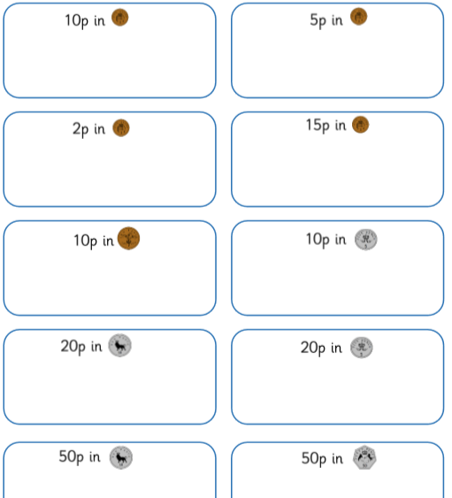

Investigate: How many ways can you make 27p? You could use the
Draw or write number sentences for all you ways. coins 1p, 3p, 3p and 20p
Has Miss Abineri found a way to pay 27p? to pay.
Maths Task 2 – Count forwards from a given number
Buy one of these things from your shop and count in fives or tens to work out how many 5p or 10p coins you will need to pay.
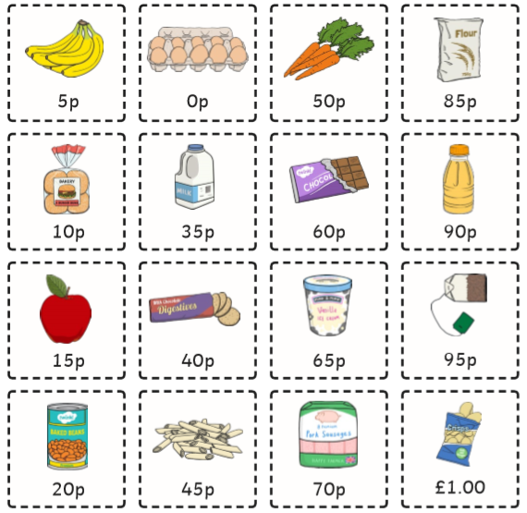

Challenge: If you paid £1 for one on these things in the shop (remember this is 100 pennies) count forwards from the amount to 100 in fives or tens to work out the change you will have left. Use the 100 square splat to help you by marking the 5s or 10s.

http://www.mathszone.net/mw/number/100sq/index.html

Maths Task 3 – Turn a full turn, half turn and quarter turn
Make cards with these words on them:
full turn half turn
quarter turn three quarter turn
Pick a word card and practice turning your body the right amount. Than cut out the pictures at the bottom or draw some of your own pictures (hearts or stickmen for example) and continue to pick cards to turn your shapes before you stick them down. (We think about anticlockwise and clockwise when we learn about time but you may begin to use these words as a challenge.)
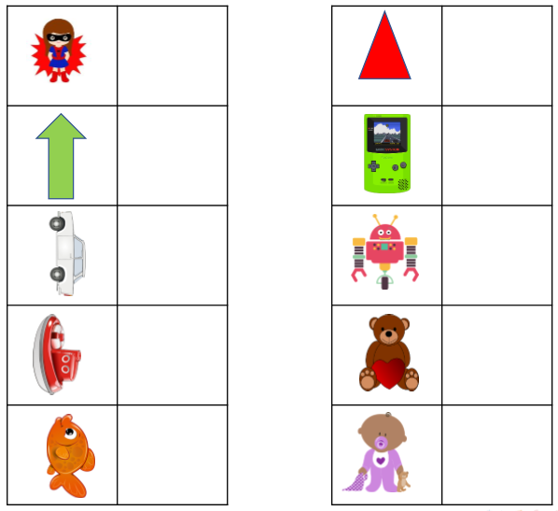
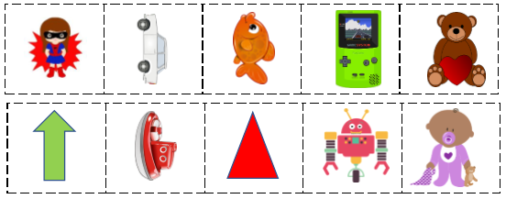
English Task 1 – Practice using the prefix un-
Write these words out on pieces of paper:
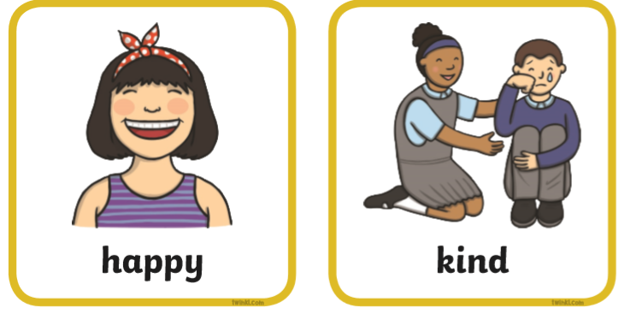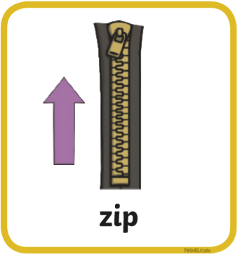
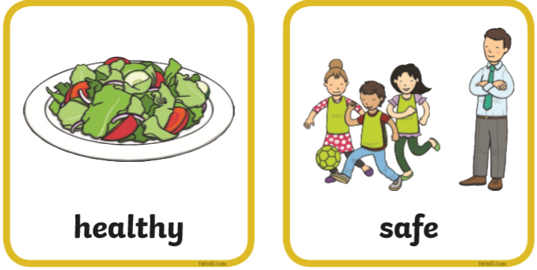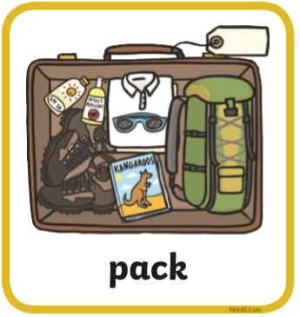

Pick a word and (without showing your grown-up) have a go at writing the word with the un- prefix on to the back of the paper.

Remember un- goes before the word.

Mime both words to your grown up. Can they guess your two words?

Talk about the difference un- makes to the words.

Can you think of any other words that you can add un- to?

English Task 2 – Describe the characters in the story
Listen to the story:
https://safeYouTube.net/w/XkhF
Here are some of Axel Scheffler’s illustrations from the story.
Write some sentences about the characters using these words:

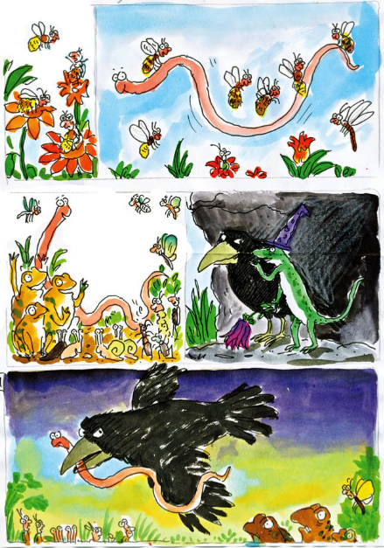
happy
unhappy

helpful

unhelpful

kind

unkind

PSHE and Science Task – Make a safety poster for Superworm’s garden
You can think about sun safety, staying safe around water and what you might look out for if you were a worm!

Give you poster a title, draw pictures and write key words or sentences.

Here are some activity ideas to help you get started:
https://www.bbc.co.uk/cbeebies/watch/sun-safety-for-kids
https://canalrivertrust.org.uk/explorers/games/waterside-safety-challenge

Phonics – Sounds ow, ou, oi and oy
The link below is for daily phonics lessons based on the scheme of work we use. Lessons appear at 10.30am every day and there are some useful guides there too.
https://www.youtube.com/channel/UCP_FbjYUP_UtldV2K_-niWw/featured

Warm Up Games: https://new.phonicsplay.co.uk/resources/phase/5
Username: march20 Password: home

Read
Sound out and write the words on paper. Later, hide them around the house and garden for a word hunt.

cow | out | oil | boy
now | shout | soil | toy
down | mouth | boil | enjoy
crown | about | coin | royal
clown | trousers | toilet | oyster

Write
No need to print – have fun drawing your own doodles to go with each word!
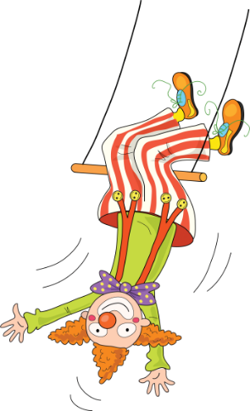
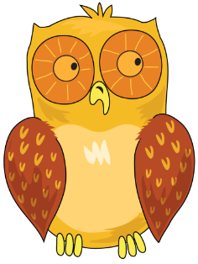
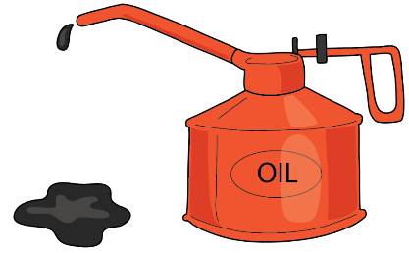
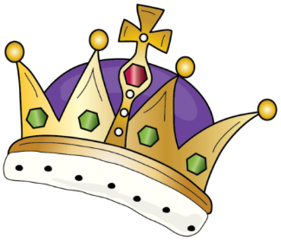
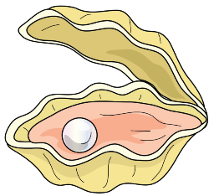

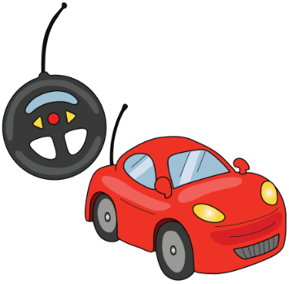

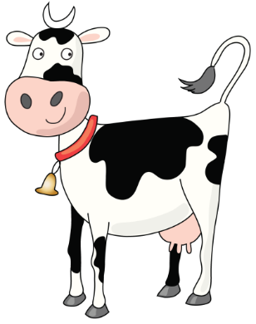
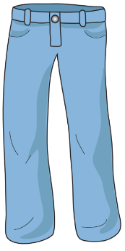
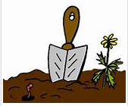

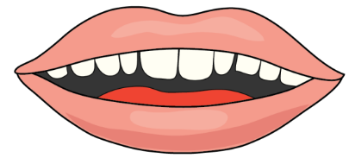

Create

Write sentences with this week’s words. If you are not sure which diagraph to use for a word, try writing it all three ways and looking carefully to see which looks right.

