Hello everyone,
At this unprecedented time, we would like to remind you that the following weeks may be difficult for some children to adapt to and comes to terms with. They have been quickly taken from their normal routines, being at school, seeing friends, attending clubs and hobbies, enjoying a full life with going out and enjoying trips and are now expected to stay at home with just their immediate family.
For the first few weeks we would suggest that you keep to the following routine and not worry too much about actual lessons. Of course you are welcome to look at the packs on each year group page but we would recommend that you stick to these activities initially:
- Read to, and hear your child read every day
- Practice times tables for all KS2 children and chanting in 2’s, 5’s, 10’s and 3’s for KS1 children.
- Enjoy time outside playing in the garden.
- Keep a physical routine going with a cosmic yoga session (found on youtube) or sign up for imoves at: www.imoves.com/imovement-signup who offer activities for parents and teachers to keep children active. It is a free service for all once you enter your name and email address.
- Talk to your children about any worries or anxieties they may feel. You could read the advice from the NHS at: https://www.nhs.uk/conditions/stress-anxiety-depression/talking-to-children-about-feelings/
- or look on the Newsround page at: https://www.bbc.co.uk/newsround/51911025 ,which has a range of articles, clips and discussions about the virus, in child speak.
- Start working through the non-screen activity sheet from Pobble
- Look at the coping calendar below
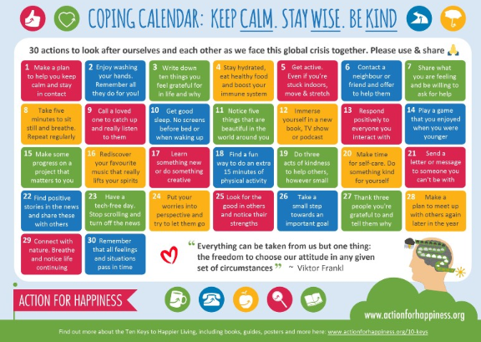
Look after each other and follow ALL advice given by the government and on news programs.
Keep well!

