Power Maths at Isleham C of E Primary School

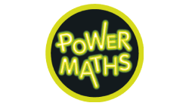
In September 2020, Isleham C of E Primary School launched the Power Maths programme across all year groups in school to re-invigorate Maths teaching and learning for all age groups.

This involves children in each class having a structured programme of learning opportunities offered each day to help them fully master the maths curriculum and develop fluency across all areas of mathematical learning.

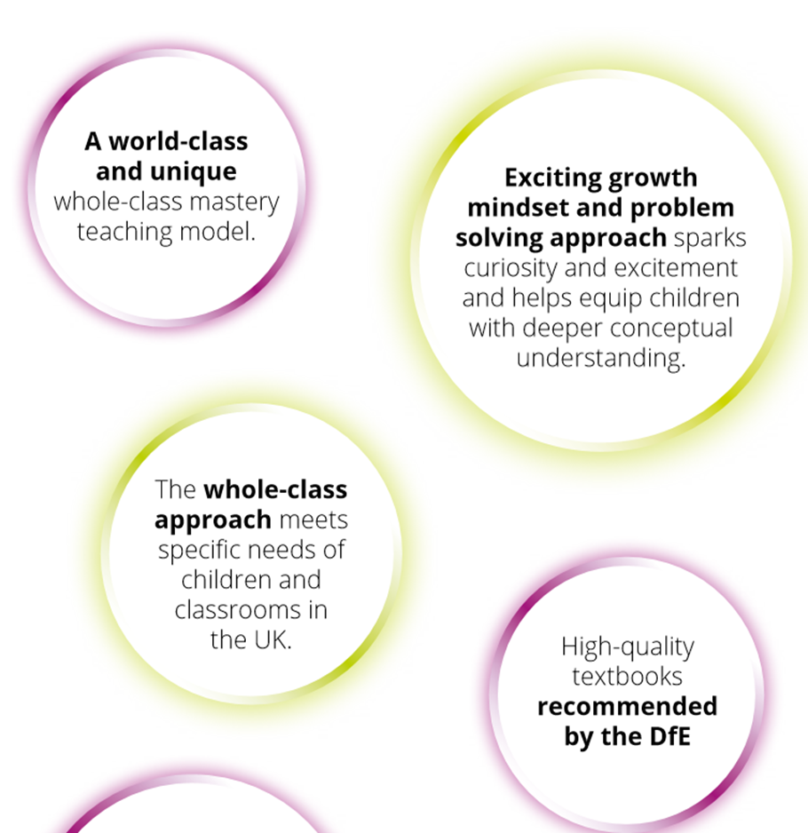

"Maths is an adventure for children (and adults) to immerse themselves in, get creative with, make mistakes, and conquer!
Power Maths is a whole-class mastery programme designed to spark curiosity and excitement and help nurture children’s confidence in maths.

Power Maths is a mastery programme perfectly aligned to the White Rose Maths progressions and schemes of learning, it’s written specifically for UK classrooms by leading mastery experts, and is recommended by the DfE."

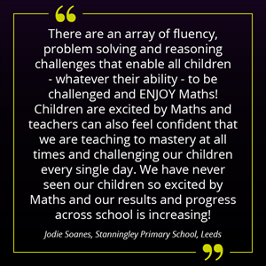

The belief behind Power Maths is that being successful in maths is not just about rote-learning procedures and methods, but is instead about problem solving, thinking and discussing. Many people feel they were taught maths in a way that was about memorising facts and formulas and calculation methods, then having to apply them without any real understanding of what or how these methods actually work. Power Maths includes practice questions to help children develop their fluency and recall of facts as well as their understanding. Power Maths uses growth mind-set (the belief that everybody’s abilities can be developed through hard work) characters to prompt, encourage and question children. They spark curiosity, engage reasoning, secure understanding and deepen learning for all.

Power Maths includes intellectually demanding and knowledge rich resources with world-class content, ideas and support.

