Progression of skills in PE

EYFS- Physical Development is a prime area of the EYFS curriculum
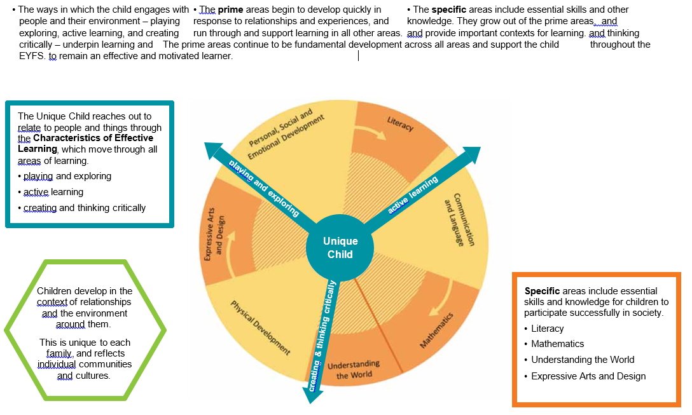
Moving and Handling | Health and Self-Care
40-60m:  -Experiments with different ways of moving  -Jumps off an object and lands appropriately  -Negotiates space successfully when playing racing and chasing games with other children, adjusting speed or changing direction to avoid obstacles  -Travels with confidence and skill around, under, over and through balancing and climbing equipment  -Shows increasing control over an object in pushing, patting, throwing, catching or kicking it  ELG:  Children show good control and co-ordination in large and small movements. They  move confidently in a range of ways, safely negotiating space. They handle equipment  and tools effectively, including pencils for writing | 40-60m:  -Shows understanding of the need for safety when tackling new challenges, and  considers and manages some risks  -Shows understanding of how to transport and store equipment safely  -Practices some appropriate safety measures without direct supervision  ELG:  Children know the importance for good health of physical exercise, and a healthy  diet, and talk about ways to keep healthy and safe. They manage their own  basic hygiene and personal needs successfully, including dressing and going to  the toilet independently

 | EYFS  Reception | KS1 |  | Lower KS2 |  | Upper KS2
 |  | Year 1 | Year 2 | Year 3 | Year 4 | Year 5 | Year 6
Dance | Copy steps and actions with some control and co-ordination  Link individual and whole body movements together  Watch others work and choose actions  Recognise how to move in space and talk about ways to keep healthy | Copy and explore basic body patterns and movements  Remember simple dance steps and perform them in a controlled manner  Choose actions and link them with sounds and music  Safely perform teacher led warm-ups and describe and discuss others work | Perform with control and co-ordination  Respond imaginatively to a variety of stimuli  Vary the dynamics, levels, speed and direction of phrase/motif  Discuss own and others work with simple vocabulary  Understand the need for warm up and cool down | Improvise freely on my own and with a partner  Translate ideas from a variety of stimuli into movement  Compare, develop and adapt movement motifs to create longer dances.  Use dance vocabulary to compare and improve work  Understand how to work safely, recognise changes in my body, give reasons why PE is good for my health |  | Demonstrate precision, control and fluency in response to stimuli  Vary dynamics and develop actions with a partner or as part of a group  Link phrases or motifs to create a wide performance  Continually demonstrate rhythm and spatial awareness  Modify own performance and that of others  Organise myself to warm up safely  Beyond Year 6:  Perform and create motifs in a variety of dance styles with accuracy and consistency  Select and use a wide range of compositional skills to demonstrate ideas and translate into performance  Suggest ways to improve quality of performance showing sound knowledge and understanding  Lead my own and others to warm up safely
Gymnastics | Copy individual and whole body movements with some control and coordination  Link individual and whole body movements together  Watch others work  Recognise and negotiate space and handle small and/or low apparatus safely  Talk about ways to keep healthy | Copy and explore basic gymnastics actions with some control and co-ordination  Select and link basic gymnastics actions together  Watch and discuss own and others work  Safely perform a teacher led warm-up and cool down and I can use space safely showing an awareness of others | Copy, remember, explore and repeat a variety of basic gymnastics actions with control and co-ordination  Select and link basic gymnastics actions into fluent short movement phrases  Identify and describe the difference between my own and others work  Handle large apparatus safely and explain the need for a warm up and cool down recognising what is happening to my body during exercise | Copy, remember, explore and repeat gymnastics actions with consistent control, co-ordination, quality and clarity  Select and link gymnastics actions fluently into longer movement phrases and apply basic compositional ideas  Describe own and others work noting similarities and differences and make suggestions for improvements  Work safely, handling a range of hand, small and large apparatus  Recognise changes in my body giving reasons why PE is good for health |  | Copy, remember, explore and repeat increasingly complex gymnastics actions with some control, co-ordination, quality and clarity  Select and link increasingly complex gymnastics actions fluently into individual, pair and group sequences and apply a variety of compositional ideas  Identify and act upon criteria to refine, improve and modify gymnastics actions and sequences  Demonstrate specific aspects of warm-up and cool down and describe the effects of exercise on the body  Beyond Year 6:  Explore and perform some complex gymnastics actions with consistent control, co-ordination, quality and clarity  Select and link complex gymnastics actions fluently into individual, pair and group sequences  Apply a variety of more complex compositional ideas showing originality  Analyse gymnastics actions and sequences and suggest ways to improve quality of performance showing sound knowledge and understanding  Lead myself and others to warm up and cool down safely and appropriately for gymnastics activities
Games | Stop a ball with some control  Send a ball in the direction of another person  Control a ball on my own  Move with a ball in space safely  Talk about ways to keep healthy | Stop a ball with basic control  Send a ball in the direction of another person and collect a ball  Take part in sending and receiving activities with a partner  Talk about exercising, safety and short term effects of exercise | Stop/catch/strike a ball with control and accuracy  Pass a ball to someone else and receive a ball when moving  Take part in conditioned games with opponents  Understand about exercising, being safe and the short term effects of exercise | Control, strike, catch a ball whilst moving and keep possession with some accuracy  Accurately pass to someone else and be aware of space and how to use it  Choose simple tactics for sending and defending  Beginning to influence the conditioned games with opponents  Describe what others do well  Talk about why it is important to warm up/cool down and lead a partner through short warm up routines |  | Control, catch, send and receive a ball accurately whilst moving and keeping to the rules  Move with a ball in opposed situations (quicksticks/football) and attack and defend in a small sided game  Take part in a conditioned game with an understanding of tactics and rules and use this to help improve performance  Understand and use principles of exercise activities for warming up and recognise how exercise is good for health  Beyond Year 6:  Control movement with a ball in an opposed situation whilst moving  Combine accurate passing skills/techniques in games  Advise and help others in their techniques in a game  Understand and explain the short term effects of exercise, warming up and cooling down  Understand and explain long term effects of exercise

 | Lower KS2 |  | Upper KS2
 | Year 3 | Year 4 | Year 5 | Year 6
OAA | Develop communication and co-operation skills in relation to problem solving skills- both verbal and non-verbal  Understand safe practice  Solve simple problems and discuss their actions  Develop communication and co-operation skills in relation to problem solving and trust skills  Give and receive verbal instructions that guide others though a pre-determined course  Listen to and follow instructions  Create and follow a range of trails that can be undertaken as a paired and also solo journey  Recognise hazards, assess the risks and take action to control the risks  Understanding what a map is and simple concepts in using a map  Develop the skills of map reading and map orientation  Plan, prepare and cook on an open fire |  | Solve a range of problems in an outdoor context or other situations  Develop co-operation and teamwork skills  Learn about different knots and how to tie them  Develop a range of new ways to solve new problems  Design and build varying sized shelters using set equipment  Work successfully as a group, consider and evaluate each member’s contributions  Compare and evaluate the shelters in relation to their sturdiness, durability, weatherproofing and whether they are fit for purpose  Learn to use a compass effectively  Develop the skills to walk on bearings and to become confident in using the compass  Set, read and follow a bearing  Developing ‘cunning running’ skills to be used in the sport of orienteering  Become confident in using the compass and map together  Set, read symbols and follow a map and/or bearing  Design and set up their own part of an orienteering event, marking up a map, sing a real punch and flag  Compete in an orienteering event

Swimming | Beginners | Improvers | Advanced
Stroke Development | Move around the pool independently  Float with the use of aids  Travel on my front and/or back with aids  Travel on my front and/or back without aids  Travel 10 metres on front and/or back without aids | Understand how to achieve a streamlined body position  Swim one stroke with good technique over at least 10 metres  Swim two strokes with good technique over at least 10 metres  Swim three strokes with good technique over at least 10 metres  Swim 25 metres competently and proficiency using at least one stroke | Understand the importance of a streamlined body position  Swim one stroke with a controlled and an efficient technique  Swim two strokes with a controlled and an efficient technique  Swim three strokes with a controlled and an efficient technique  Swim at least 25 metres using front crawl, backstroke and breastroke
Confidence and Skill Development | Blow bubbles  Submerge whole head  Float without aids  Push and glide  Jump into the water* Unable to jump INTO our pool for safety reasons. Children could jump IN the water e.g. lift feet off bottom of pool | Push and glide  Submerge to pick an object off the bottom of the pool  Combine different floating shapes  Perform a sculling action  Jump into deep water* Unable to teach jumping INTO water in our pool due to safety reasons. Aim to use Sport Premium Funding to teach this element in a local swimming pool. | Tread water  Perform a sculling action  Demonstrate surface dives*  Unable to teach this element due to safety reasons. Aim to use Sport Premium Funding to teach this element in a local swimming pool.  Demonstrate a range of safe entry techniques* Unable to teach this element due to safety reasons. Aim to use Sport Premium Funding to teach this element in a local swimming pool.  Identify areas of good technique and areas of improvement

 | EYFS  Reception | KS1 |  | Lower KS2 |  | Upper KS2
 |  | Year 1 | Year 2 | Year 3 | Year 4 | Year 5 | Year 6
Athletics  Events | Running within the lanes on a track  30m run  Novelty sports day races and obstacles | Running within the lanes on a track  40m run  Novelty sports day races and obstacles | Running within the lanes on a track  House team relay races  50m run  Novelty sports day races and obstacles | Athletics Challenges- Triathlon  50m Sprint  400m Middle distance  Practise and refine running, jumping and throwing techniques  Introduce an alternative throwing technique  Introduce a 3rd (slinging) throwing technique  Explore jumping for height  Introduce throwing for accuracy and distance  Explore jumping for distance using different techniques  Participate in a multi-activity athletic event  Judge and measure others’ performance fairly and consistently  Record own and partner’s performance | Athletics- Pentathlon  50m Sprint  400m Middle distance  Refine running, jumping and throwing techniques  Refine throwing for accuracy and distance  Introduce and practise the approach and take-off when jumping for distance  Refine slinging for accuracy and distance  Introduce the approach and take-off when combining jumps for distance  Refine putting for accuracy and distance  Introduce and practise the bat on handover for relay running  Participate in a multi-activity athletic event  Judge and measure others’ performance fairly and consistently  Record own and partner’s performance | Athletics- Heptathlon  75m Sprint  600m Middle distance  Heptathlon  100m hurdles  High jump  Shot put  200m  Long jump  Javelin throw  800m  Further refine running and jumping techniques  Extend the approach when jumping for distance  Introduce and practise sprint starts and finishing  Refine running, jumping and throwing techniques  Refine discuss throw for accuracy and distance  Extend the approach for triple jump  Refine hurdling over barriers  Refine javelin throw for accuracy and distance  Explore alternative techniques when jumping for height  Develop team relay effectiveness  Practise running, jumping and throwing techniques for athletic competition  Rehearse officiating and accurate measurement for athletic competition  Participate in a multi-activity athletic event  Judge and measure others’ performance fairly and consistently  Record own and partner’s performance | Athletics- Decathlon  75m Sprint  60m Sprint hurdles  600m Middle distance  Decathlon  100/110m hurdles  High jump  Shot put  Discus throw  100m  400m  Long jump  Javelin throw  1500m  Understand and experience interval training to improve fitness for athletic competition  Work effectively with a training partner to complete the demands of the training session  Understand and experience circuit training to improve fitness for athletic competition  Understand and experience long slow distance training to improve fitness for athletic competition  Practise running, jumping and throwing techniques for athletic competition  Rehearse officiating and accurate measurement for athletic competition  Participate in a multi-activity athletic event  Judge and measure others’ performance fairly and consistently  Record own and partner’s performance accurately

