Year 1 Home Learning 27.04.20

Dear Year 1 and families,
Thank you for all of your hard work last week. We really enjoyed seeing everything you’ve been doing and I hope you enjoyed doing the activities too. I hope you are all staying safe and well at home.
This week our main theme is a story and there is some science and writing related to the story. I have added your activities to your portfolio for you to have a go at this week so as usual there is some active maths, practical maths and some number work as well as a set of phonics sounds for the week.
Remember if you are doing other things at home you can upload pictures of those as well, to let me know what you are doing.
This week we are going to share some examples of your classmates’ work once they’ve had a go at the activities, to inspire you to have a go at them if you are a little bit unsure.
Take care of yourself and enjoy the story.
See you next week.
Miss Abineri

Year 1 Home Learning 27.04.20
Maths Task 1 – Investigate capacity
https://whiterosemaths.com/homelearning/year-1/
Watch Week 1, Lesson 4 and 5 and Week 2 Lesson 1
(There are further activities on this website but they are paper based and not practical so the following is this week’s practical investigation.)

Measure the capacity of some different containers from your home by counting how many cups of water they hold. Draw your results like this:
Can you compare the containers? For example

The jug holds more than the
pan because it holds 6 cups
and the pan holds 4 cups.

Think about Teddy’s measuring and record a video explaining what you think:

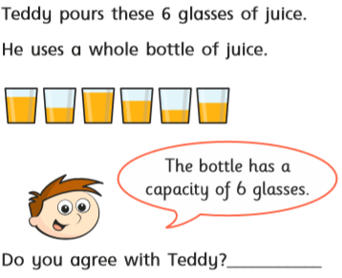

Maths Task 2 – Add equal groups
https://whiterosemaths.com/homelearning/year-1/
Watch Week 2, Lesson 3 and 4

Draw these pictures (5 bikes, 3 hands) and write the number sentences to go with them. Make some problems of you own with things you have at home, for example I have 12 spoons so I could sort them into equal groups of 2 and write the number sentence.
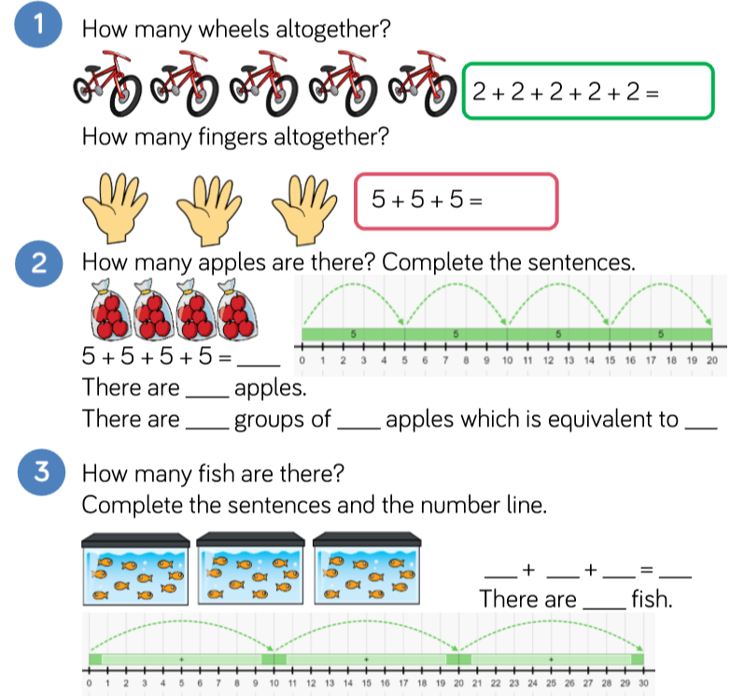

Challenge: Miss Abineri has 7 cookery books. Could you help me sort these into equal groups and write a repeated addition number sentence?
Explain what you think in a video.
Maths Task 3 – Represent tens and ones
Pick some numbers up to 100.
Choose two things to represent tens and ones. In school we use dienes which have long pieces for the tens and small cubes for the ones so it would help to choose a longer and shorter thing – try long and short lego bricks, sticks and pebbles from your garden or even movements such as a star jump for tens and a squat for ones. Represent the numbers with your things.
Example: 64 would be 6 sticks and 4 pebbles or 6 star jumps and 4 squats.
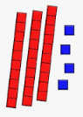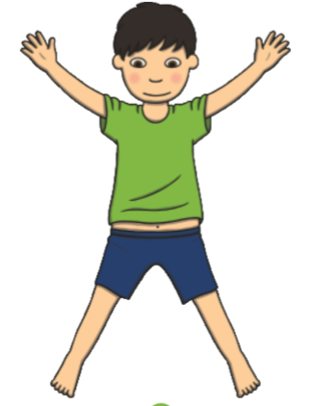

Science and Art Task – Types of plant
Watch
https://www.bbc.co.uk/bitesize/topics/zpxnyrd/articles/zw2y34j
Listen carefully to the scientific words for the two types of trees:
deciduous and evergreen, see if you can remember and use these words.
Draw and label a selection of things from your garden or places where you walk. Choose different types of things such a tree that has blossom, a tree that didn’t lose its leaves in winter, plants with big flowers, small flowers and no flowers. Use these words to label your different pictures.

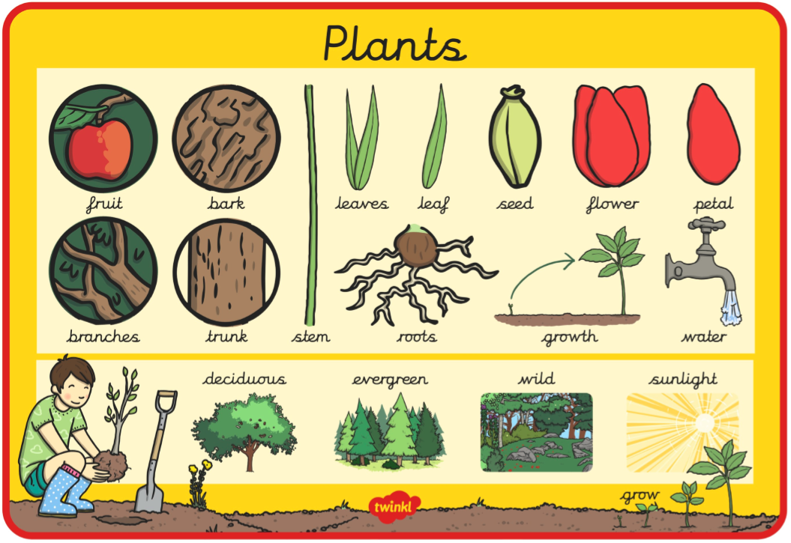

English Task 1 – Choose ideas for a story
Listen to the story ‘The Gigantic Turnip’ on our Class Story.
Here’s how to create some ideas for your own story.
These are the nouns and adjectives in my story:
turnip  gigantic | man  old
woman  old | cow  big  brown
cat  black | mouse  hungry  little

Split your page into six sections and choose six nouns to write in each box.
You can choose a different plant for them to pull up and any characters you like so use your imagination. Maybe your story could be set in another place or even on another planet!
After you have chosen your plant and characters choose some interesting adjectives and add these.

English Task 3 – Write your story.
Write your story using the words you have chosen and some of these verbs:
helped pulled heaved
tugged yanked

You can keep it simple with these ideas, no need to repeat as many sections as the book:
Beginning – Where do they live? What is the plant?
Middle – Who helps pull up the plant?
End – What happens when the smallest animal helps?

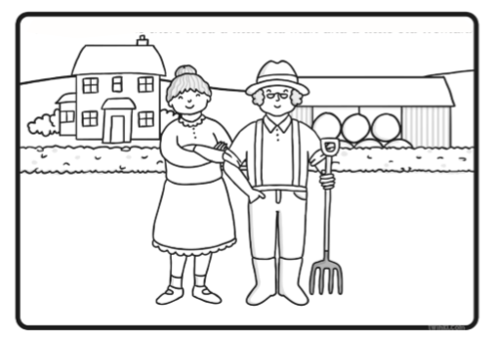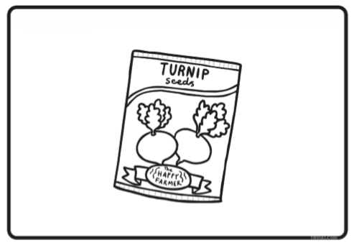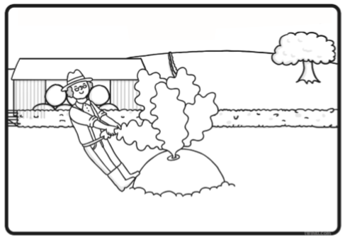
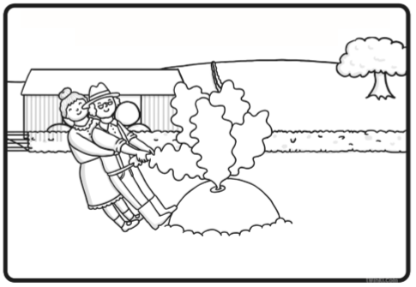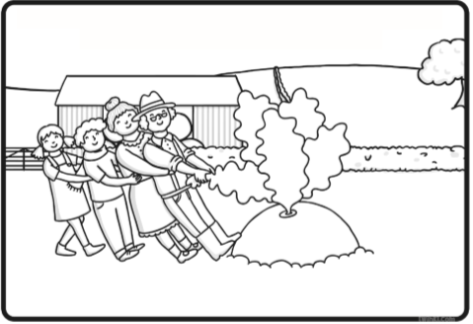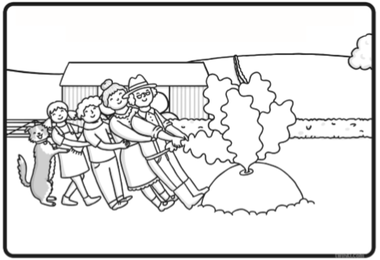
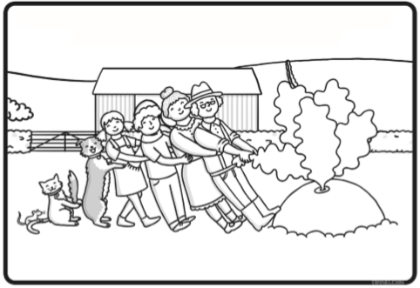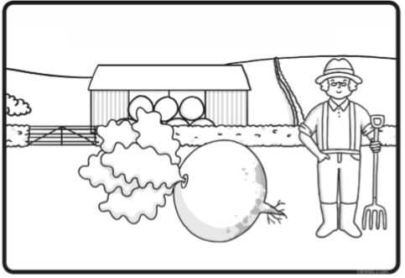
Remember to give you story a title and add an illustration if you like.

Phonics – ee, ea, ey, e-e
The link below is for daily phonics lessons based on the scheme of work we use. Lessons appear at 10.30am every day and there are some useful guides there too.
https://www.youtube.com/channel/UCP_FbjYUP_UtldV2K_-niWw/featured

Warm Up Games: https://new.phonicsplay.co.uk/resources/phase/5
Username: march20 Password: home

Read
Sound out and write the words on paper. Later, hide them around the house and garden for a word hunt.
tree | meat | key | theme
cheek | leaf | donkey | evening
sleep | read | chimney | concrete
creep | team | trolley | delete
sheep | speak | turkey | complete

Choose the sounds ee, ea, ey and split e-e on this website for word searches and games:
http://www.galacticphonics.com/home/long-vowels/

Write
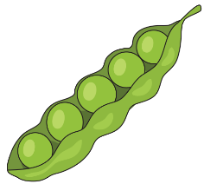
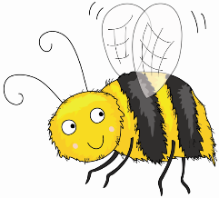
No need to print – have fun drawing your own doodles to go with each word!
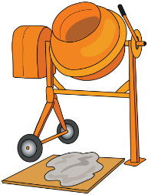

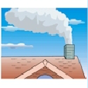
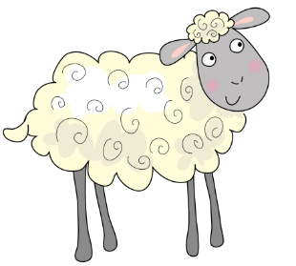

Create
Write sentences with this week’s words. If you are not sure which diagraph to use for a word, try writing it all three ways and looking carefully to see which looks right.

