Class 4!
Welcome to week 3 of home learning. You have been busy and we will now begin to attach a selection of home learning from you each week - do take a look!
Here are the winners of our reading competition:
1st place – Henry Tilbrook (over 300 pages!)
2nd place – Ted Winters (over 200 pages!)
3rd place – Lilly Winters (over 100 pages!)
A big well done to you three, and to everyone else who has been doing lots of reading this week. Miss Bottomley managed 80 pages of Bad Dad by David Walliams (reading to her daughter) and has nearly completed Fen Runners by John Gordon (another 50 pages), so didn’t quite read as much some of our winners! Remember, you might also want to send a video of you reading for Basil the dog. Some people have already sent videos – thank you, Basil will be pleased
Have a great week!
Miss Bottomley and Mrs Airey
Maths task 1 – tenths and hundredths
The White Rose Maths Hub sets tasks each week to try from home. We recommend trying the lesson ‘Make a Whole’ which explores deeper the work we have been learning on tenths, hundredths and decimal numbers. We have attached the activity worksheet for you to try. Send a photograph of your completed work.
Feel free to explore the site further at https://whiterosemaths.com/homelearning/year-4/
Maths task 2 – 12 x Times tables
Place number cards with the answers to the 12 x table around the garden or a room in your house. Ask someone to call out questions and run to the correct answer (idea borrowed from a year 4 parent – thank you!). You could extend this activity by timing yourself to collect the cards in ascending (going up) or descending (going down) order. What else could you do with your number cards? We look forward to finding out! Submit learning as a video.
Maths task 3 – Statistics
Line graphs
Line graphs are often called time graphs and are used to show how something changes over time. Data could be collected hourly, daily, weekly or monthly depending on what you need the data for. Watch this video showing how the information on a time graph is used then have a go answering the question sheet
https://www.youtube.com/watch?v=N5eaVBwmTq4
Now have a go at answering one - or more - of these sheets. Don’t forget, you can just write the answers down if you don’t want to print the sheets off.

English task 1 – Spellings
This week’s 10 spellings are:
Year 3/4 spellings
certain
knowledge
ordinary
earth
fruit

adding the prefix auto- ( meaning self or own)
autograph
autobiography
automatic
autopilot
automobile

A creative way to learn them is to complete the spelling roll-a-word activity. You will need a dice for this activity and the picture in the attachments will show you what to do each time you roll the dice. Let us know how many spellings you learnt by submitting your score out of 10 as a Text Entry.
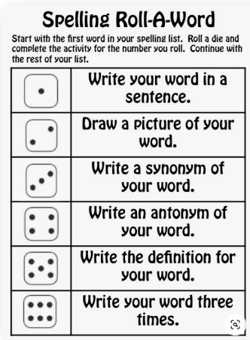

English task 2 – Punctuation
Have a go at the punctuation quiz PowerPoint. Let us know how you got on by writing a Text Entry. Tell us what you could do well and what you need to work on further.
English task 3 – Reading
Listen to Miss Bottomley read the opening of Fen Runners by John Gordon (recommended age 9 – 12 years). This is a children’s book set in the Fens that explores the tradition of Fen-skating. When two young boys go swimming and unearth a piece of metal, they also unearth a mysterious legend.
An author can spend a long time writing the opening to their story. Can you think why? I like the opening to this story because it is filled with mystery. Immediately one of the characters, Kit, puts himself in danger when he gets stuck beneath the water and we are wondering whether he will survive. Soon after we are left wondering what the piece of metal is that Kit has brought up from the bed of the channel. I really enjoyed the beautiful, almost poetic language used to describe the setting and action, such as, ‘Above them the ripples of their plunge had fled to the grassy banks and died.’
Find a book you think has a good story opening. Think of the reasons you like the opening to the story. Now record yourself reading the opening few paragraphs, followed by an explanation of why you choose the story opening.
Find out more about Fen Skating and the Fens by following this link:
https://www.youtube.com/watch?v=8AgK-exnRec
Topic task – Science
In Science this term we are going to be learning about States of Matter.
Look at this BBC bitesize page to find out about the 3 different states of matter. Watch the video clip, read the information and then have a go sorting the objects near the bottom of the page.
https://www.bbc.co.uk/bitesize/topics/zkgg87h/articles/zsgwwxs
Everything you can see, (and some things you can’t see) is matter and can be grouped as either a solid, a liquid or a gas. Look around your house and/or garden and decide whether things would come under the group title solid, liquid or gas. Record them in an organised way. Were any tricky to decide?

