December Newsletter
Message from the Head Teacher
We are ending the term almost as busy as the start of it, with lots of exciting events to take part in before we break up for the Christmas break.
The plans are underway for an exciting Christmas Fair, organised by the Parent Teacher Association (PTA) who are raising funds for more technology in school and to support the cost of coaches for class trips. These events take a huge amount of organisation behind the scenes to make them successful, so if you are able to support in any way then please sign up on the online sheet or ask in school. The fair will be full of games to attempt, a barbecue for food, Santa to visit, teas and coffees and of course a tombola and raffle, all started off with the school pupils and children in the choir singing.
There are still lots of opportunities for the children to be part of the community; through the KS2 choir singing for the residents at Limestone class, the whole choir singing at the end of the festival of lights, the house captains preparing food parcels for families who need support and of course the whole school community contributing to the food or clothing bank.
Next term we begin our new collective worship focus of ‘courage.’ From Samuel, 2, verses 10 – 12, we hear to, ‘Be of good courage, and let us be courageous for our people, and for the cities of our God.’ We will be teaching the children to show courage by standing up for others, being positive when others are being negative, and getting involved in groups or clubs. Being courageous in school can sometimes be as simple as raising your hand and asking questions. Maybe the Spring term is the time to try out a new club. Please see the club timetable for more details.
I wish you all a very happy Christmas and hope to see the children back at school on the 5th January 2022.
Dawn Deacon

Staffing
It is with great sadness that we will be saying goodbye to Mrs Foster at the end of this term. She has been teaching in Year 4 to cover the maternity time of Mrs Stevens-Ward, but has now accepted a permanent teaching position in another school. Hopefully you will agree that she has been a great caretaker of the Year 4 class and fitted into the Isleham way, seamlessly. We wish her well for her continued teaching time.

After Christmas the Year 4 class will have Mrs Taylor as their teacher until Mrs Stevens-Ward returns. She has been in school many times over the past year and so knows the children well and really enjoys being with them. I am sure that you will give her a warm Isleham welcome.

Diary Dates

Wednesday 07.12.22 Festival of Light visit for all classes to attend

Friday 09.12.22 Year 4 class assembly

Sunday 11.12.22 School Choir to sing in St Andrews Church from 4pm

Tuesday 13.12.22 Years 1 and 2 trip to see Dick Whittington and his Cat – Arts Theatre, Cambridge

Tuesday 13..12.22 KS2 choir members to sing at Limestone Close

Thursday 15.12.22 Christmas Jumper day with the Christmas Lunch

Friday 16.12.22 School Christmas Fair 4pm – 6pm

Monday 19.12.22 Christmas Craft Day

Tuesday 20.12.22 Year 4 residential trip to Burwell House

Wednesday 21.12.22 Last day of term

Wednesday 04.-01.23 Professional Day – SCHOOL CLOSED TO PUPILS

Thursday 05.01.23 Children return to school

Junior Travel Ambassadors (JTA)
Some children in Year 5 have been chosen to become the JTA group for this year. They have already held an assembly to teach about crossing the road safely and held a competition to make new banners to display on the school metal fence. There were over 30 entries and it was challenging to chose the winners, but they have been chosen and are being printed, so that they can be presented to the school after Christmas, and provide the winners with their prize bags.

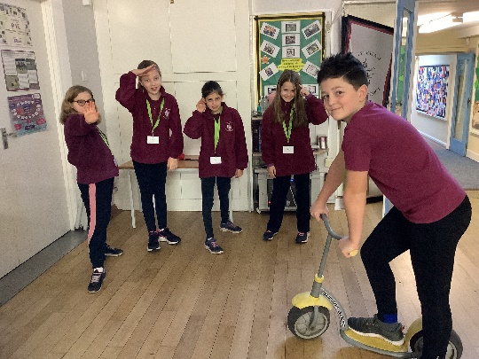

Key Stage 1 Christmas Production
The rehearsals are in full strength for the performances to take place next week. Everywhere in school the songs are in full force and with the stage now up the children will be moving to the hall for walking on and off the stage. Tickets have been allocated by Year group but don’t forget to send back those that do not suit you, or will not be used, so that others may have them instead.
Spring Term Clubs
 | Before school | Lunch time | After school until 4pm
Monday | Dough Disco with Miss Simmons 8.15 – 8.45 (chosen children only)
Tuesday |  |  | Cookery club with Mrs Deacon for group 3 -already full
Wednesday |  | Library club with Mrs Gibbs Y6 librarians and Years R-3 | Coding Club with Mr Walker  Years 3-6  Dance with Premier Sport  Years 1-4  Netball with Mr Tull Years 4, 5 and 6
Thursday |  | TT Rock stars with Mrs Barnes-Weston  (chosen children only)
Friday |  | Choir group with Miss Eatock all welcome

Performance 1: 2pm on the 14th December 2022
Performance 2: 9.30am on Thursday 15th December 2022
Performance 3: 9.30am on Friday 16th December 2022

Club list
Please see the clubs that are available for the children over the coming term. If your child(ren) would like to take part then please send a message to the office, or directly make contact with me via classdojo.
We try to offer a range of opportunities, but if there is something that your child would enjoy, then please ask them to suggest it to me and all ideas will be considered.

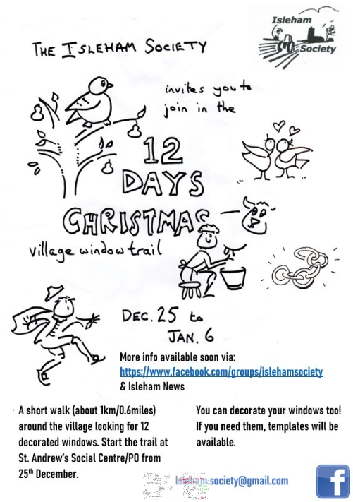

The School Visit the St Andrews church festival of lights
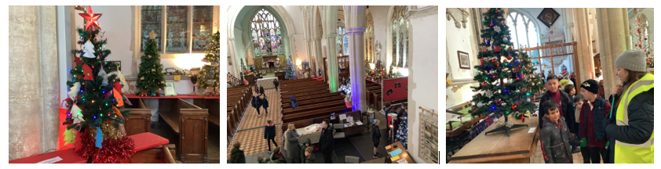

This Year the school have become involved with the Isleham Society. The children will create a display for those who go on their walk around the village searching for the signs of the 12 days of Christmas. I won’t say much more, as it will not be a secret, but please take part if you can and look out for our contribution!

The society members are also planning a singing carols session on Thursday 22nd December, in the St Andrew’s Social Centre. If you enjoy carol singing then why not join them from 6pm – 7pm.

On the 7th December 2022 the whole of the school visited St Andrews church to see the Festival of Lights. We all noticed the decorations on the school tree, that were made by the Year 5 children. We also thought about Jesus being the light of the world, as well as enjoying all of the differently decorated trees!

