September 2023 Newsletter – 3rd Edition
Message from the Head Teacher
Thank you to Miss Williamson, for her excellent newsletter of last week. The aim is for me to send the news to you, in a formal way and then every other week, Miss Williamson will bring the celebration of the children’s work.

This last week we saw parents in school, hearing all about the year ahead for their children, with routines and expectations shared, with each class teacher. They will share their power points with you for those who were not able to attend, so that you can continue to support your child with routines. Thank you to everyone who was able to be in school for these sessions. It is always wonderful to have parents in school.

This year, there is a clear expectation for all maintained schools to sustain a good attendance level for all children. The school will be held accountable for lower attendees and will be challenged about how we support families. We already hold regular meetings and track the children who are lower in their time at school. This will continue, but you may also face receiving some standard letters if the attendance percentage falls lower. I know how hard it can be if your child is unwell, and the challenge of deciding if they should attend school is difficult to navigate. Please see the site https://www.nhs.uk/live-well/is-my-child-too-ill-for-school/ to help you decide if your child should be attending, or not. Don’t forget that, if they have an upset stomach, they should not attend school for 48 hours after the last time that they were ill. This helps to keep the bugs from spreading across the school. Otherwise, please refer to the link.

My final message is a thank you. Thank you to all of the staff, along with some parent helpers, who have agreed to help in the school, and/or provide a club. Without this generosity of time, the school would not be able to provide such a rich offering to the children.

With regards, Dawn Deacon
Collective Worship
We are still learning about being part of a community and how to work well together, no matter what the differences. The children have heard biblical stories about how Jesus chose his special friends and how they were all very different but worked together for a common message. Rev Steve shared a fun story about the first 4 disciples that Jesus gathered together. He even brought in some fabric fish to explain the story. Maybe your child(ren) can explain the biblical story to you.

So that there should be no division in the body, but that its parts should have equal concern for each other. If one part suffers, every part suffers with it; if one part is honoured, every part rejoices with it. (Corinthians 12: 25-26)
Harvest Festival
I hope that you have all taken note of the Harvest Festival date, which is, Friday 29th September 2023. We welcome you all to join us at St Andrews Church in Isleham, for the school service. We will aim to leave school as soon at the registers are taken, and walk down in class groups. You are welcome to help with walking down to the church, or you could meet us there, for a 9.30am start.
This year, we are once again requesting food items for the food banks, both at the school gate as well as the Ark Community Pantry. Please can you send tinned food items, dried pasta, pasta sauces and packets of rice.
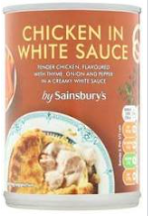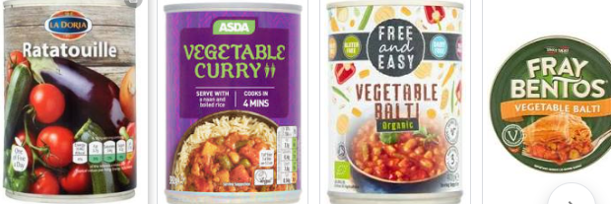
Each class will perform a short piece for the service, and the collectively decorated church board will be on show.
Absence Request
Please could I remind everyone that if you intend to take your child out of school, to complete a leave of absence form. Medical appointments do not need one, but all other reasons for taking your child out of school does need a form. Cambridgeshire County guidance is very clear that any holiday that is 3 days or more will incur a fine. Please note, that the school has to follow this policy and no holiday situation can be granted as authorised.
I am really sorry for any upset this causes, or bad feeling between the school and home, but we are bound by the Local Authority guidance.


The school food bank would like to offer families a meal, so things such as pasta sauces and pasta, tinned pies and potatoes, curry sauce and rice. Please send in these items as well as tinned soup, tinned vegetables and tinned fruit. Last year, we were all amazed by your generosity and kindness.
Ordering Uniform
If you would like to order uniform please go directly to the Goodies site https://www.gooddies.co.uk/product-category/schools/isleham-c-of-e-v-c-primary-school/ where you can purchase all that you need for school. Don’t forget to name ALL of your child(rens) belongings to ensure that it is returned to them if it is lost in school.
