July 2023 Newsletter
Message from the Head Teacher
This will be my last newsletter of the year, and what a year it has been! I cannot believe that it is over, and while I sit here and ponder all of the learning in the school, not only for the children but the adults too, especially me, I know that we could not have done it without the support of parents/carers as well as the amazing staff.

You only have to consider the recent disco. There was a good number of staff to help with the setting up, support of the dancing and seeing the children out, but there were also many parents who supported. We could not have held the event without your help, and I thank you. The event also raised £75 for the PTA funds, so a good time had as well as some money towards other resources and facilities in school.

There have been many other times too, that parents have given their time freely to ensure that the children have wider opportunities in school. Swimming support, woodland visits, Christmas Fair, discos, trips, fundraising and other background events too ie, PTA meetings and Governor’s support. These extra events could not have occurred without you all!

The children have worked hard to be successful in their year groups and I hope that you have been pleased with their reports. It has just been such a pleasure to have another year at Isleham Primary School, and I know that all of the staff have enjoyed working with your children – they are all very special to us!

I wish you all a safe and happy holiday and thank you for all of your support this year.

With regards,
Dawn Deacon



Return in September 2023
Remember that the first day of school on the 1st September, is a professional day and so no children will be in school.
Years 1-6 will have their first day back, on Monday 4th September.
The new reception children will receive their home visits between 4th – 6th and then start full time school, for all, on Thursday 7th September 2023.
School Uniform
I have already mentioned that footwear should be totally black, please, as well as a plain coloured PE shirt, of the house team. If the school burgundy t-shirt still fits for PE, then please keep wearing it until it is outgrown.
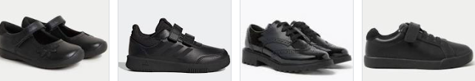


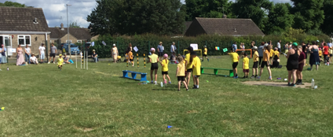
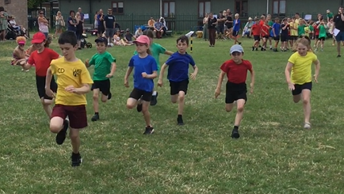
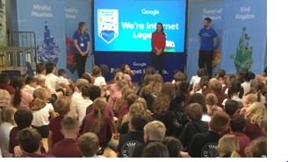
Sports Day
Sports day was an incredible success this year. Here are some photographs of some of the events.

Lucy Frazer visit
We were lucky to have a visit from Lucy Frazer, MP, a few weeks ago. She was in school to find out more about the safer internet assembly that the children in Years 2-6 heard. She also spent some time in the reception class, as they shared their maths learning about how to make 10.
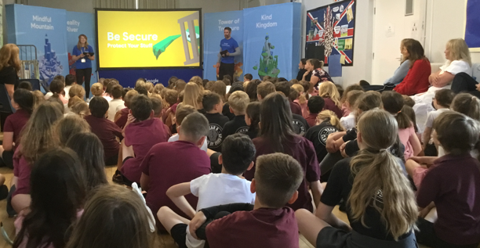

Junior Travel Ambassadors
In June our JTA team were invited to a celebration of all of the groups of Year 5 and 6 children who had been supporting travel and road safety, over this academic year. The Isleham group represented our school so well, took part in games and activities and saw all of the scrapbooks that were created by other schools. They had a great time and it was a fabulous ending to their role.
If any of the present Year 4 children were thinking that they would like to be involved with the scheme next year, then they should speak to me and think about what they could bring to the role. A new team will be chosen in September!
