October Newsletter
Message from the Head Teacher
It has been a fantastic month in school so far, with a successful harvest festival, rock steady music lesson and also a speed stacking session for each pupil. The school has a great community feel at the moment and the children are showing their fantastic learning behaviours.
The next term is no different, and there are a range of engaging and interesting learning opportunities ahead. Please see the diary dates for details of forthcoming events and which year group is involved.
The collective worship time has been spent thinking about community and how each and every member of the school can work as a team to achieve great things. As our motto says, ‘letting their light shine’, which I see so many times as I walk around the school, as the children help each other, are respectful to the adults helping them and using kind words to each other.
Dawn Deacon

School responsibilities
The Year 6 held an informed and passionate husting session to gain the votes of their house team members. There were some impressive speeches, which have provided the leadership team with several ideas for the future, to convey the reason that they should be chosen. Once voting took place and these were counted, the children who had been successful were excited for their new role and those who had sadly lost out, were gracious in their defeat.
Already the children have spoken about more playground equipment as well as clearing the pond and representing the school in a variety of ways. They are going to be very busy over the year ahead! All classes have now chosen their school council and eco council members and meetings are taking place each week. Look out for further details of their actions in coming newsletters.

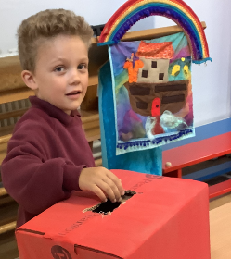
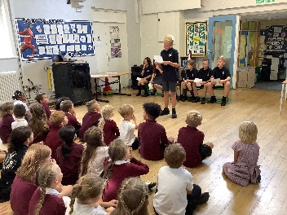

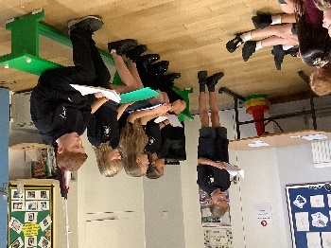

Start and end times of school
Please can I remind all parents that the start time for school is at 8.55am. If parents are dropping off after this time we do keep a record of consistent lateness, so please try to be at school before this time. The children are welcome to access the school from 8.40am.
From next week, the children who arrive at school early, will be encouraged to walk around the edge of the playground, so that they use their waiting time to gain some of their recommended 60 minutes of exercise each day.

Diary Dates
Friday 14.10.22 Year 6 STEM challenge at SVC

Monday 17.10.22 Year 4 parent meeting – Burwell House residential details – the hall, 3.20

Tuesday 18.10.22 Year 4 Greek Day in school

Thursday 20.10.22 Parent meeting sessions for parents of children on the SEND register and other chosen children

Friday 21.10.22 – Black History Day for all classes

Monday 24.10.22 to Friday 28.10.22 Half Term – NO SCHOOL

Wednesday 02.11.22 1st Flu vaccination

Thursday 03.11.22 Evening 1 – Parent Consultations

Monday 07.11.22 Evening 2 – Parent Consultations

Tuesday 08.11.22 Diwali celebration day and house day – children to wear their house colours

Sunday 13.11.22 House captains to lay wreath for Remembrance Sunday

Thursday 01.12.22 2nd Flu vaccination

Tuesday 20.12.22 Year 4 residential trip to Burwell House

Wednesday 21.12.22 Last day of term

Wednesday 04.-01.23 Professional Day – SCHOOL CLOSED TO PUPILS

Thursday 05.01.23 Children return to school

Healthy lunch boxes
At Isleham C of E School we teach children about making health food options and learn about cooking food in the design and technology lessons. The kitchen also provides fruit and vegetable choices each day for those wishing to take the option of a school lunch.
Therefore, can I please remind parents who are sending their child to school with a packed lunch that it also should also contain a range of healthy food options. Myself and the staff have seen some children with chocolate bars, 2 packets of crisps and up to 4 yoghurts in their lunch boxes. All of these foods contain unhealthy constituents and some have a huge amount of hidden sugars. These foods are fine for a treat and can be eaten at home, but for brain development and the ability to concentrate, school should be a place to develop healthy choices and ‘brain’ food. I do hope that the photographs provide some more ideas of what could be included in the home produced lunch box.
Uniform
I am sorry to remind everyone again about the uniform expectations, but some children are still not wearing the totally black footwear that is requested.
Shoes and trainers are expensive, so I am not enforcing an immediate change, but could I please request that you choose totally black footwear when you purchase new footwear. Thank you for your support with this matter.

