February 2023 Newsletter 2
Message from the Head Teacher
Welcome back to the second half of the Spring term. I am really seeing the signs of Springtime, not due to the flowers of trees and bulbs developing or the increased warmth, but instead due to the number of coats that are being removed during playtimes! At the end of the first half term I looked out of the window to see a row of about 20 or 30 coats hanging along the metal railing and I thought to myself, ‘That’s a sure sign that Spring is in the air!’ Please do keep sending you child to school with a light coat though, as we go outside even in light rain and a fleece is not enough of a layer to keep the children dry.
This remains of this term will be busy with any Easter celebrations as well as a house day, golf day, science days and parent consultations. Don’t forget, if you haven’t already, do make a booking to visit your child’s class teacher. The teachers are currently preparing a report about the children, to show their strengths and areas for development, as well as their Autumn assessment scores. These will be handed out at the parent consultation, or sent to you after the Thursday consultations, if you are unable to make the meetings.
For those of you who requested some details about the academic year, 2023-2024, then please see dates below. The governors have now confirmed the days that the school will use for staff development. More details will be placed on the school website.
As always, please speak to either myself or any member of staff if you have any queries.
Dawn Deacon
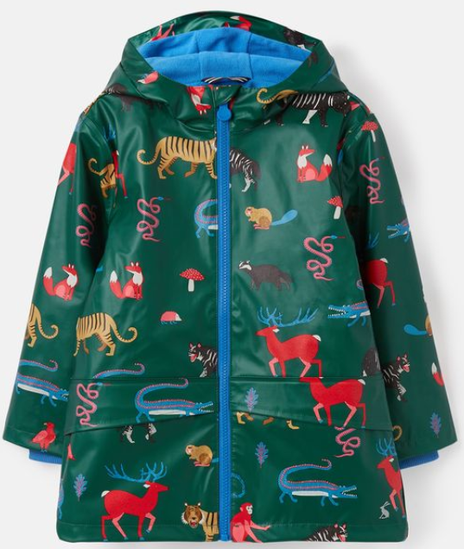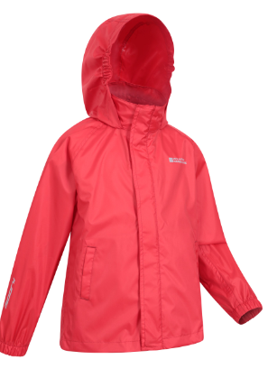

Class Cafes
Thank you to the parents who have been able to attend the class cafes, so far. These have varied enormously in their content, depending on the year group and the expectations for the end of year. The Year 4 and 5 presentations also involved the parents/carers, with some multiplication and division questions for them to attempt, as well as a times table competition.
There are still some year groups to hold their sessions.
Year 6, 24.02.23
Year 3, 03.03.23
Reception, 10.03.23
Year 2, 17.03.23
Please do attend if possible.

School term and holiday dates for 2023/2024
Diary Dates

Tuesday 21.02.23 Parent Consultation, 3.30pm – 6pm (session 1 of 2)

Wednesday 22.02.23 House Day – Special Me, Special you – please wear house colours – plain if possible – Parent session at Fordham school – 4-5pm with a creche provision

Thursday 23.02.23 Parent Consultation, 3.30pm – 6pm (session 2 of 2)

Tuesday 28.02.23, Wednesday, and Thursday, Year 4 parent consultations in the classroom

Wednesday 01.03.23 PTA meeting

Friday 03.03.23 Year 6 House Captains Cake Bake fundraising for Children against Cancer

Wednesday 08.03.23 Golf Day, for all classes – please wear PE kit all day

Friday 31.03.23 Last Day of term –Isleham’s Got Talent

Monday 17.04.23 Staff Professional Development – NO CHILDREN IN SCHOOL

Tuesday 18.04.23 Children return to school for the Summer Term

Autumn Term dates
- Friday 1 September to Friday 20 October 2023 (36 days) PD day Fri 1st Sep
- Half Term: Monday 23 to Friday 27 October 2023
- Monday 30 October to Wednesday 20 December 2023 (38 days)
- Christmas Holidays: Thursday 21 December 2023 to Wednesday 3 January 2024 PD day Wed 20th Dec

Spring Term dates
- Thursday 4 January to Friday 16 February 2024 (32 days)
- Half Term: Monday 19 to Friday 23 February 2024
- Monday 26 February to Thursday 28 March 2024 (24 days) PD day Mon 26th Feb
- Easter Holidays: Friday 29 March to Friday 12 April 2024

Summer Term dates
- Monday 15 April to Friday 24 May 2024 (29 days)
- Half Term: Monday 27 to Friday 31 May 2024
- Monday 3 June to Monday 22 July 2024 (36 days) PD day Mon 3rd June and Monday 22nd July
- Summer Holiday: Tuesday 23 July onwards

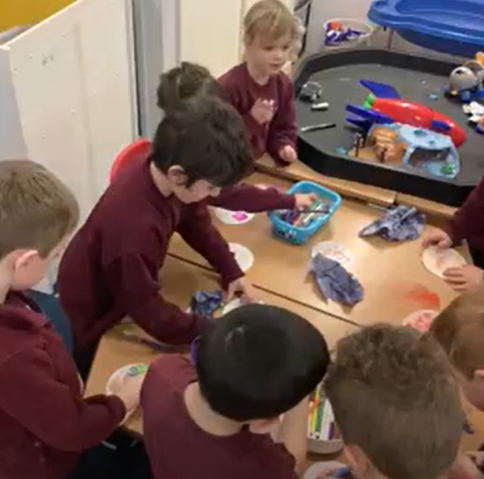
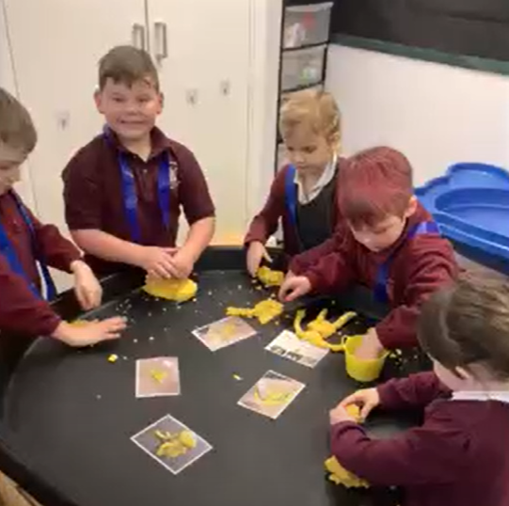
Bring and Buy Sale
Towards the end of the Spring term the Year 6 house captains will be holding a bring and buy sale to raise funds for an outside trim trail. No date has been set just yet, but we ask if you are able to send in any items – ‘to bring.’ We are able to receive these as soon as possible to allow time to prepare and price.
These should be in good condition, either new, or in the original box and hardly used.
Possibly the following:
- Cuddly toys
- Books
- Games
- Colouring books
- Pens or pencils
- Notebooks or stationery items
Once enough items have been sent into school the team will inform you of more details of the sale. We really do hope that you will support this fundraising effort so that the school can purchase some items for the school field. We have some support from the PTA and the sports premium funding but we still need more to allow a full circuit to be created.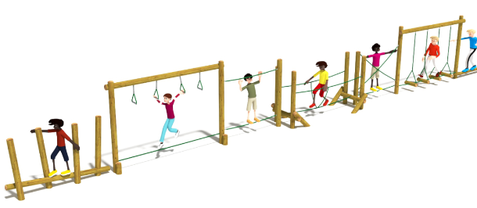Photographs
To end the newsletter, I have included a range of photographs from Years 1, 2 and 3. Year 1 are discovering more about space, Year 2 are in the woods and Year 3 are using spy glasses!

