Safe Touch Policy

Isleham Church of England Primary School

September 2020

1.Legal framework
  - This policy has due regard to the following legislation, including, but not limited to:
- The Children Act 1989 & 2004
- The Childcare Act 2006
- Equality Act 2010

1.2. This policy also has due regard to the following guidance:
- DfE ‘Use of reasonable force in schools’ 2013
- DfE ‘Working together to safeguard children’ 2018 (updated Feb 2019)
- DfE ‘Keeping Children Safe in Education’ 2019
- Cambridgeshire Steps- ‘Step-On’ Training 2019-20
1.3. The school will implement this policy in conjunction with our Safeguarding Policy, Health and Safety Policy, Behaviour Policy and Equality Policy.
2. Roles and responsibilities
2.1. All members of staff at our school have a duty of care towards pupils and must be aware of the boundaries involving physical contact.
2.2. The Headteacher is responsible for conducting annual safeguarding training for all members of staff and ensuring that they are aware of their responsibilities, in line with the school’s Safeguarding Policy.
2.3. The Headteacher is responsible for ensuring that all staff engage in safe touch with pupils, and only where absolutely necessary in line with the whole school Cambridgeshire Steps training.
2.4. All members of staff are responsible for ensuring that no pupil feels threatened or unsafe at our school as a result of inappropriate touch.
2.5. All members of staff have a responsibility to report any instances of inappropriate touch to the Headteacher.
2.6. The Headteacher is responsible for communicating with parents/carers and ensuring that they are aware of this policy.
2.7. The school has a responsibility for ensuring that they create and promote a culture in which pupils’ wishes and feelings are respected.

3. What is safe touch?
3.1. For the purpose of this policy, “safe touch” is defined as physical contact that, if otherwise avoided, would be inhumane, unkind and potentially emotionally or physically damaging for the pupil.
3.2. Safe touch should never be invasive, humiliating or flirtatious.
3.3. The school understands that the following examples are instances of safe touch which may occur between staff and pupils:
- Comforting an upset or distressed pupil
- Congratulating or praising a pupil
- Holding the hand of a pupil for reassurance or to guide them, such as when crossing a road or walking to assembly
- Giving first aid to a pupil
- Demonstrating exercises or techniques during PE lessons, administering medicine or when using musical instruments

4. Types of safe touch
4.1. The school recognises that:
Any physical intervention should be in the student’s best interest and should be conscious of the need to differentiate the attachment to staff from the attachment to key adults such as parents and siblings. Regardless of age, physical intervention should not provide intimacy within a transient relationship. (Cambridgeshire Steps, 2019)
4.2. The school advises that the most appropriate places to touch pupils are on the shoulders, arms and back. However, if the adult or child are not comfortable with any physical contact, the adult should move away and opt out, unless to do so would put the child or others at immediate risk of harm.
4.3. The school advises staff to use a closed mitten hand formation to draw a child closer, and an open mitten for guiding or hand holding.
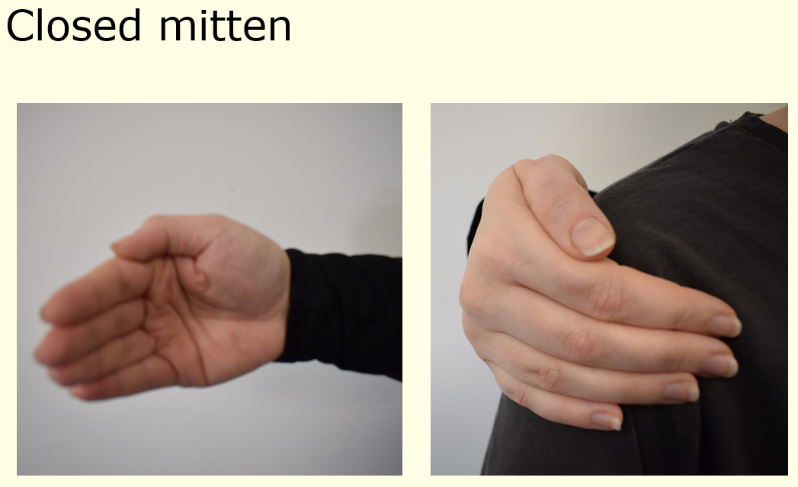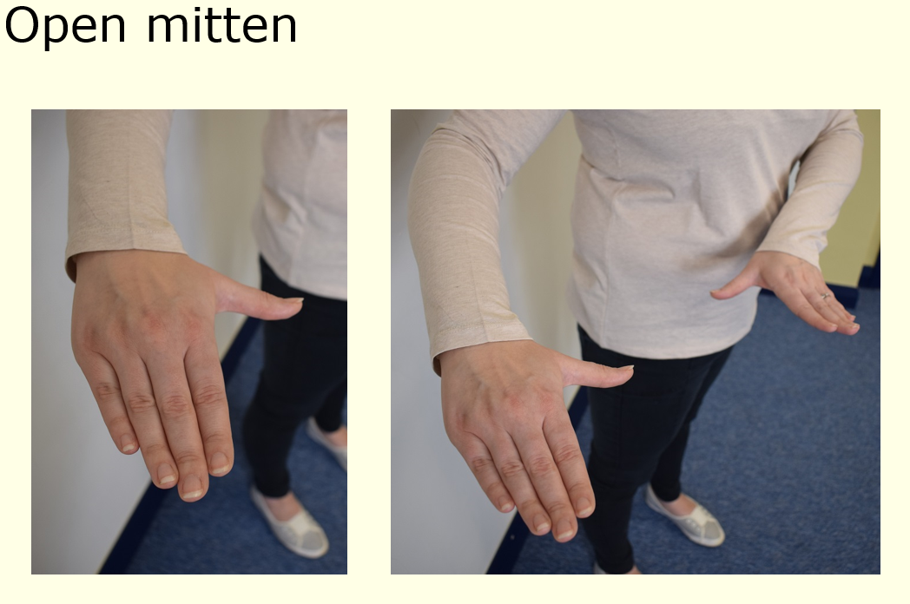
4.4. The school places the following restrictions on hugging:
- At our school we encourage staff using touch for reward or comfort to use the ‘school-hug’, rather than an embrace. (The school-hug is a sideways hug whereby the member of staff places their hands on the pupil’s shoulders. This type of hug prevents the pupil from turning themselves towards the member of staff and thus engaging in a ‘front’ embrace, which the school would deem inappropriate.)
4.5. The school places the following restrictions on holding hands:
- At our school we understand that there are times when a member of staff may hold a pupil’s hand, either to guide them or to prevent them from being physically harmed.
- Within our Reception class, Year 1 or Year 2 we may also hold a pupil's hand when giving guidance, reassurance or to comfort them.
- We encourage the use of the ‘school hand-hold’. This is done by the adult holding their arm out with an ‘open mitten formation’, and the child is encouraged to either hold the hand or arm of the adult or wrap their hand around the adult’s lower arm. The adult’s other hand can then be placed over the child’s hand for a little extra security if it is required.
4.6. The school places the following restrictions on lap-sitting:
- The school recognises that it may be appropriate for a child in Reception, Year 1 or Year 2 to sit on a staff member’s lap if they require comfort or reassurance, particularly in the case of extreme distress; this type of contact is only made with the consent of the child e.g. at no point should the child be held in position. The child should sit across the adult’s lap so that a supportive school shoulder hug can be given.
4.7. The school understands that pupils are not always aware of the boundaries between staff and pupils and thus may try to engage in physical contact such as lap-sitting or inappropriate hand-holding and hugging
4.8. Should a pupil try to engage in any inappropriate physical contact, the member of staff must explain to the pupil why it is unacceptable and encourage them to engage in the school-hug.
4.9. If a member of staff attempts to use one of the safe methods of touch and a pupil is unhappy with this, the member of staff will retract immediately in order to respect the pupil’s wishes, unless to do so would put the child or others at immediate risk of harm.
4.10 School staff will always offer to help to change and/or clean a child who is wet or soiled unless parents specifically request for this NOT to happen or the child refuses to be helped by a member of staff (in this situation, parents will be contacted to collect and support their child). In these situations, the adult will afford the child as much privacy as possible by remaining nearby e.g. in a toilet cubicle doorway and will hand items to the child e.g. clean clothes/ wipes etc to enable him/ her to do as much as possible for him/herself. Please see the school’s intimate care policy for further guidance.
5. Reasonable force
5.1. The school understands that there are times when members of staff must provide physical intervention whereby a child presents danger to themselves or others.
5.2. All staff have the legal power to use reasonable force. In these instances, staff must always explain the reasons for their actions to the pupil and why it is/was necessary.
5.3. Reasonable force may be required in order to control or restrain a pupil in extreme circumstances, such as needing to guide a pupil to safety.
5.4. At all times, members of staff must ensure they use reasonable force in such a way as to avoid any injury to the pupil, but the school recognises that in some extreme cases, such as immediate intervention to prevent worse physical injury, this may not be possible.
5.5. The school is able to use reasonable force in situations when:
- Disruptive children must be removed from the classroom, and have previously refused to.
- Members of staff need to control/ separate disruptive pupils on school trips or similar
- Members of staff must prevent a pupil from leaving a classroom when doing so would lead to a risk of their safety.
- A pupil is attacking a member of staff or another pupil.
- A pupil is at serious risk of harming themselves and a member of staff must intervene to prevent this. (DfE, p.5)
5.6. Any occurrences of the use of reasonable force will be reported to the Headteacher, who will keep a written record of this and communicate it to the pupil’s parents/carers. In cases of extreme behavioural need, a care plan may be drawn up in conjunction with the child, his/ her parents or carers and any other outside agencies which details ways in which an individual may need to be held or supported. Any recommended physical contact will be detailed in the plan and will be in line with recommended practice for school staff as mentioned in Cambridgeshire Steps training, 2019. No physical restraint should ever cause a negative impact on the process of breathing, pain as a direct result of the technique or a sense of violation. In these instances, please see section 6 below.
6. Reporting inappropriate touch
6.1. If a pupil attempts to engage in any inappropriate touch, the member of staff involved will report this immediately to the Headteacher, in order to prevent any allegations of inappropriate physical contact.
6.2. If another member of staff suspects or witnesses inappropriate physical contact, whereby the member of staff is willingly involved, they will report this to the Headteacher immediately.
6.3. The Headteacher will keep a written record of all instances of reported inappropriate touch.
6.4. Any allegations against staff will be dealt with as a matter of urgency, and in accordance with the procedures outlined in the Staff Code of Conduct.

7. Training of staff
7.1. The Headteacher will conduct safeguarding training for all members of staff in relation to safe touch.
7.2. All staff will be regularly reminded of the methods of safe touch employed by our school, and will communicate this to the pupils they are in contact with.
7.3. Training by the school’s Step-On tutors (Sarah Skillern and Dawn Deacon) will take place at least annually for all staff (Step On training).

8. Monitoring and review
8.1. This policy is reviewed on an annual basis by the Headteacher, who will make any necessary changes and communicate this to all members of staff.
Last reviewed: 1.9.20
Review date: on or by 1.9.2021

