Week Beginning 23rd January 2023 - Newsletter
Message from the Head Teacher
There will be a further newsletter, in addition to the monthly one sent out at the beginning of each month. Our school improvement adviser has suggested that I produce a second newsletter, so that communication remains effective between home and school.
One main message to bring to you all is around safety in the playground. We are reminding children not to stand on the icy areas of the ground and to walk whenever possible.
Please can we also ask that children do not use the climbing equipment or climb on the gazebo area (that we call the quiet zone) at the end of the day. When the children use this equipment during the day, it is supervised by the staff and carefully monitored. The staff are not available at the end of the day to ensure it is used safely.
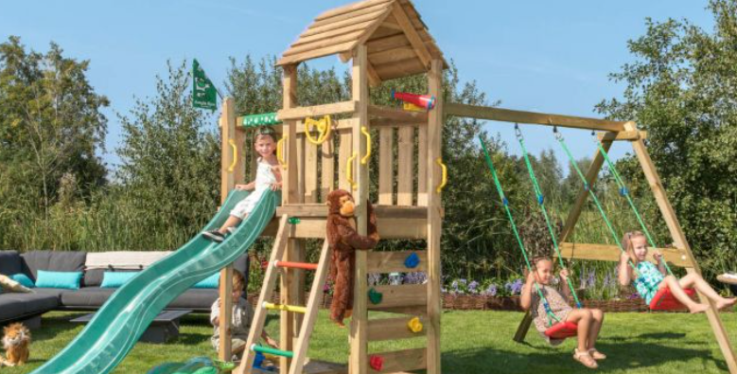
As our Christian value is courage, for this half term, I would still love to hear about any times when the children from school have shown great bravery. We will create a book of courage if we hear enough examples of bravery. It could be anything; such as illness or competition, or just doing something that was previously causing anxiety!
Dawn Deacon
Parent Forum
We would like to invite parents to a forum to hear about the focus areas of the school, to share successes and for everyone to have a voice. This will be held on Friday 3rd February at 2.30pm. All welcome!

PTA Disco – Fri 03.02.23
The school PTA are holding a disco at a price of just £3 per child. The children are split this time into 3 groups as follows:
Reception, Year 1 and Year 2 from 5pm until 6pm
Years 3 and 4 from 6pm until 7pm
Years 5 and 6 from 7pm until 8pm.
If there are any parents who are willing to support this event by helping out and supervising, then please let me know by sending a direct classdojo message.
You will have needed to complete a recent DBS and also attended a safeguarding session.

Road Safety Banner Competition
Diary Dates

Friday 27.01.23 Chinese New Year themed afternoon

Friday 03.02.23 PTA organised Valentines Disco (split over 3 sessions according to age)

Wednesday 08.02.23 SEND/longer parent consultations by invitation

Friday 10.02.23 Last day before the half term break

Monday 20.02.23 Children return to school

Tuesday 21.02.23 Parent Consultation, 3.30pm – 6pm (session 1) Not Year 4!

Wednesday 22.02.23 House Day – Special Me, Special you – wear house colours, please

Thursday 23.02.23 Parent Consultation, 3.30pm – 6pm (session 2) Not Year 4!

Wednesday 08.03.23 Golf Day, for all classes

Friday 31.03.23 Last Day of term – possibly Isleham’s Got Talent

Monday 17.04.23 Staff Professional Development – NO CHILDREN IN SCHOOL

Tuesday 18.04.23 Children return to school for the Summer Term

The JTA group excitedly shared the names of the runners up and winners of the recent banner competition, today. The winners have had their banner designs made up for display on the metal railings on the entrance to the school. They are already up, so that everyone can see them.
The Key stage 1 winning design was by Ethan in the reception class with Sophie D in Year 1 being a close second. In Key stage 2 there were so many great entries that made it a challenge for the team to finalise the winning design, but eventually the drawing by Millie in Year 5 was picked as the winner, with Ethan, also in Year 5 being the runner up.
Well done to all who entered and remember to use the advice on the banners, when you cross the road. Stop, look, listen, before you cross.
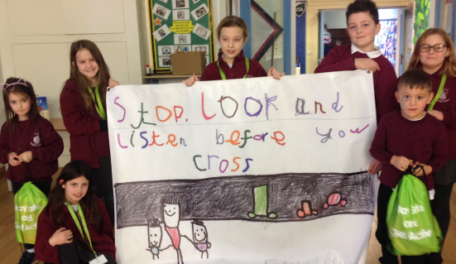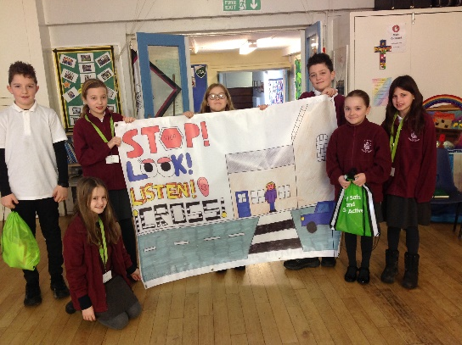The JTA team would also like to remind you not to park, at any time, on the zig zag lines outside of the school - it is illegal!
Photos of learning from across the school
