November Newsletter
Message from the Head Teacher
The school has been just as busy as the previous month with speed stacking, STEM challenge, Black History Month focus and even an initial parent meeting session, as well as all of the usual learning that takes place in each classroom. I am always incredibly proud of the children as they attempt each task to the best of their ability and adjust well to the changes in routine.
November is no different in its busyness, with the usual class based and whole school learning opportunities. Please see the dates below for more details of these exciting events.
We are also starting a new Christian value theme, in the collective worship time, with compassion being at the centre of our focus. We will be thinking about the feelings of others as shown in the bible quote; ‘Be kind and compassionate to one another, forgiving each other, just as Christ God forgave you. Rejoice with those who rejoice; mourn with those who mourn. Finally, all of you, be like-minded, be sympathetic, love one another, be compassionate and humble.’
We have already shown this compassion in school, by setting up the food larder. If you or anyone you know of, need food, then please ‘take what you need.’ If anyone is able to donate, then we are looking for more pasta sauces, which can be handed into the office at school. The food we are presently using was provided from the harvest festival, so thank you very much for the support that you have already provided.
Dawn Deacon
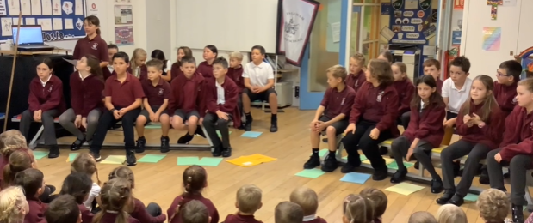
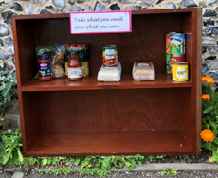Class Assembly Presentation
Last week the Year 5 started the class assembly presentations with a bang, as they shared their learning about the Victorian era. With artwork, songs, biography readings and even a chimney sweep, they have set a very high standard for the rest of the school to follow. Here are the dates of future year groups:
04.11.22 Year 1
18.11.22 Year 2
25.11.22 Year 3 (possibly 2.45pm)
02.12.22 Year 4
09.11.22 Year 6

Congratulations
Diary Dates
Wednesday 02.11.22 1st Flu vaccination

Thursday 03.11.22 Evening 1 – Parent Consultations

Monday 07.11.22 Evening 2 – Parent Consultations

Tuesday 08.11.22 Diwali celebration day and house day – children to wear their house colours

Friday 11.11.22 Year 6 to visit the war memorial in Isleham

Sunday 13.11.22 House captains to lay wreath for Remembrance Sunday

Monday 14.11.22 Anti Bully Week

Friday 18.11.22 BBC Children in need event – wear non-school uniform or spotty cloths for £1 donation

Friday 25.11.22 Christingle service at St Andrews Church, 9.30am

Thursday 01.12.22 2nd Flu vaccination

Tuesday 20.12.22 Year 4 residential trip to Burwell House

Wednesday 21.12.22 Last day of term

Wednesday 07.12.22 Festival of Light visit for all classes to attend

Sunday 11.12.22 School Choir to sing in St Andrews Church

Tuesday 13.12.22 Years 1 and 2 trip to see Dick Whittington and his Cat – Arts Theatre, Cambridge

Wednesday 04.-01.23 Professional Day – SCHOOL CLOSED TO PUPILS

Thursday 05.01.23 Children return to school

We are so proud and excited to be able to share some news about a Year 4 pupil from Isleham C of E School. Holly will be performing in the West End, London in the production of ‘A Christmas Carol.’ We saw her shine, when she took part in Isleham’s Got Talent last year, but to pass the audition for a West End Production is a testament to her talent, zest for performing and her overall resilience. I am sure that you will, like us, wish her every luck for her performances. Holly, you will put Isleham on the map and be a great representative of our school! ‘Let your light shine!’

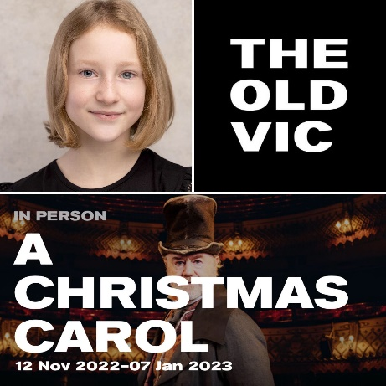

Sporting Events
In October the school welcomed the Witchford sports partnership coaches into school for a whole day of speed stacking, the competition where the children learn hand and eye coordination to stack cups in different ways. Each class took their turn to take part in the event, and all thoroughly enjoyed their time in the hall.
These skills were used to great effect when a team of Year 5 and 6 children entered a local competition. Overall, they represented the school well, but one team gained a second place in the event. A huge well done to all who attended!
Poppy appeal
The school has a range of poppies to sell to raise funds for the Royal British Legion, if children would like to purchase one. These will be brought to the classrooms from Monday the 7th November 2022. Please send your child to school with the £1.00, if you wish them to purchase their own poppy.
Eco School
The children have chosen their class representatives for attending weekly Eco council meetings. We are now placing all compost waste into a bin and are still collecting crisp packets. These packets are then prepared to send to Terracycle who provide funding to charities in exchange for the waste. The man in Isleham, who collects these bags has asked us to also provide empty coffee bags, so if you have any of these then please bring them to school for recycling. With thanks.
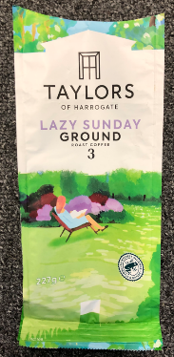

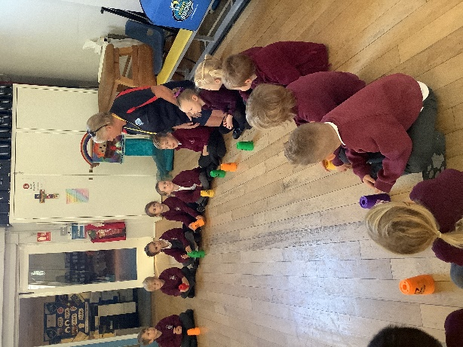

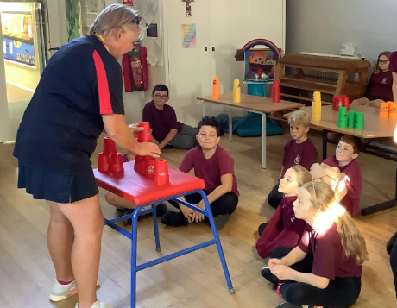

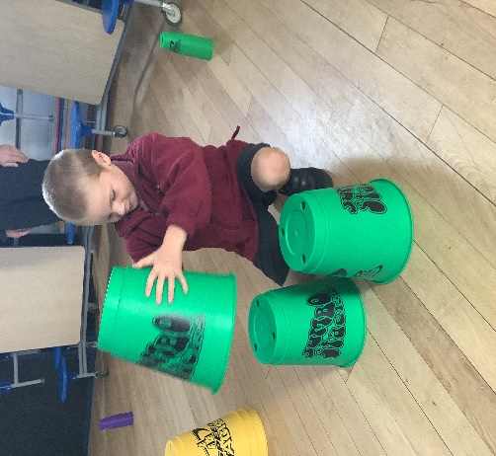

Key Stage 1 Christmas Production
This year the reception class will be joining with Years 1 and 2 for their Christmas production. There are 3 main performances when parents/carers can attend. The school is letting you have these dates now so that arrangements can be made with employers, if you wish to attend.
Performance 1: 2pm on the 14th December 2022
Performance 2: 9.30am on Thursday 15th December 2022
Performance 3: 9.30am on Friday 16th December 2022
More details, tickets etc will be sent out nearer the date.

PTA Christmas Fair
This year the PTA would like to hold a Christmas fair, in the playground of the school. This will take place on Friday 16th December 2022 from 4pm until 6pm.
There will be a visit from Father Christmas, stalls and games, the opportunity to eat a hot dog or burger and to start the proceedings, songs from the whole school and the school choir.
If you are able to help in any way, then please send a message to the school office and you will be added to the fair WhatsApp group to discuss events and details.
We would also welcome any raffle or tombola prizes, to be with the school by Friday 2nd December 2022.
This should be lots of fun and also raise some funds for the school. The children have requested some more playground equipment, and the possibility of fitting a trim trail!

This year the house captains want to support a few charities. One of them is ‘Children Against Cancer,’ where the children will set up some cake bake sales, but also they wanted to celebrate ‘BBC Children in Need.’ This charity event will be held on Friday 18th November. To raise money, we ask for donations of £1 per child to wear either spotty item of clothing, or non-school uniform.

