February 2023 Newsletter
Message from the Head Teacher
Remember that this the final week of the Spring half term and that the children will be starting their holiday, this Friday, and not returning to school until Monday 20th February 2023.
Even with a shorter number of weeks, the school staff have still enabled a huge amount of extra opportunities for the children to have memorable experiences. They have taken part in; Chinese New Year craft tasks, story telling week, new road safety banners competition, planting an orchard, as well as a huge quantity of different clubs and after school provision. The level of work produced is also high, and the children will like to show their learning at the imminent parent consultation meetings.
Parent consultation booking is about to become available. If you have 2 or more children, please don’t forget to make your time slots 10 minutes between. All slots will become live on Wednesday 8th February at 12.30pm. The deadline for making a booking will be on the 20th February, so you have plenty of time to arrange a meeting, but don’t forget to ask in the office if you are finding the technology difficult to use!
Thank you to the parents who attended the parent forum last Friday. Even with just 6 families in attendance, there were still opportunities to answer questions about the provision in school and a chance to bring to our attention, ways to improve the school. One further session will be arranged for the summer term, so please look out for the date and try to attend if possible.
Dawn Deacon
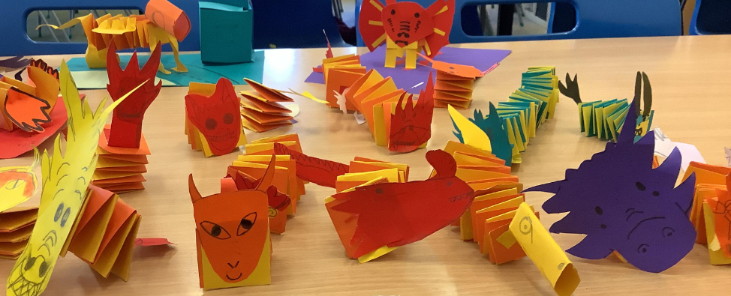
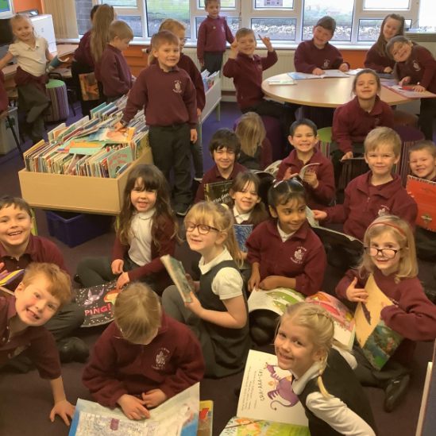

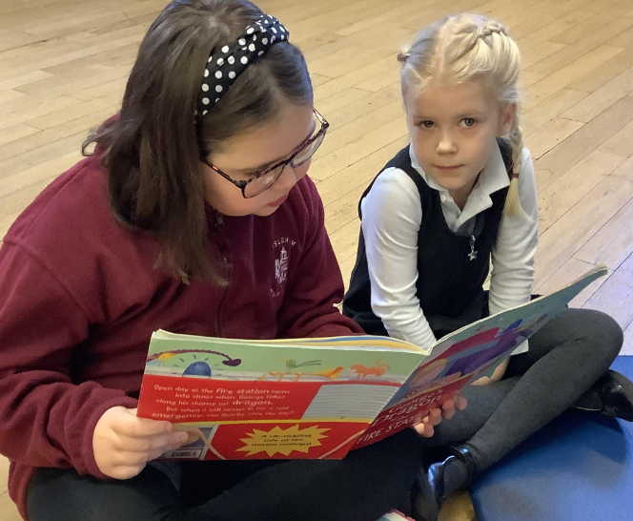

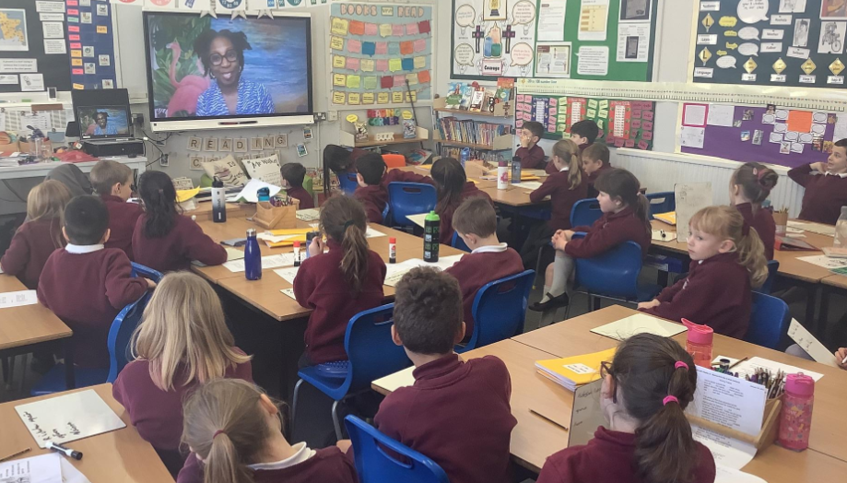

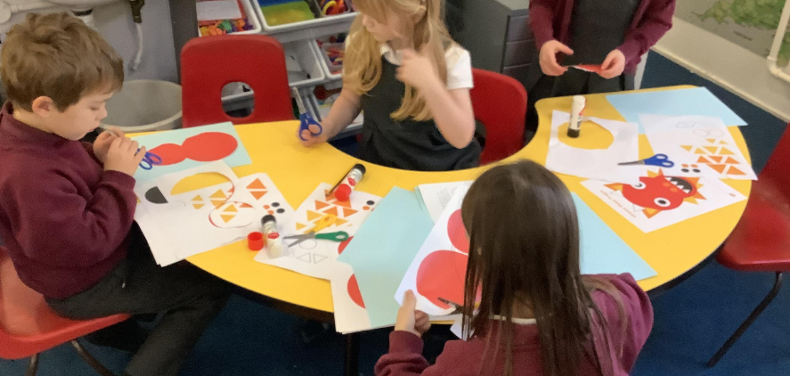

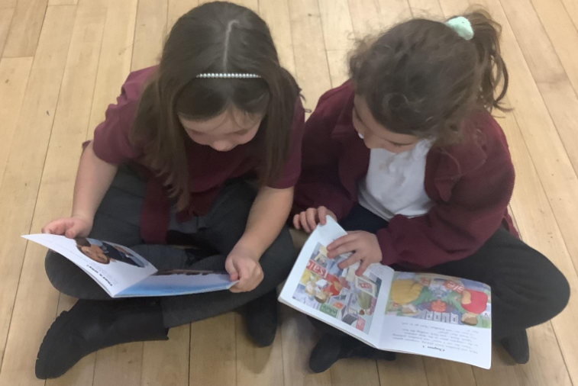

Special Me, Special You, House Day
Diary Dates
Wednesday 08.02.23 SEND/longer parent consultations, by invitation

Friday 10.02.23 Last day before the half term break

Monday 20.02.23 Children return to school

Tuesday 21.02.23 Parent Consultation, 3.30pm – 6pm (session 1)

Wednesday 22.02.23 House Day – Special Me, Special you – wear house colours, please

Thursday 23.02.23 Parent Consultation, 3.30pm – 6pm (session 2)

Tuesday 28.02.23, Wednesday, and Thursday, Year 4 parent consultations in the classroom

Wednesday 01.03.23 PTA meeting

Friday 03.03.23 Year 6 House Captains Cake Bake fundraising for Children against Cancer

Wednesday 08.03.23 Golf Day, for all classes

Friday 31.03.23 Last Day of term – possibly Isleham’s Got Talent

Monday 17.04.23 Staff Professional Development – NO CHILDREN IN SCHOOL

Tuesday 18.04.23 Children return to school for the Summer Term

On 22nd February, we are lucky enough to have the truly inspirational, Darren Edwards, visiting our school in the afternoon, after he has visited Fordham School in the morning, to talk about his experiences of over-coming adversity, how to develop resilience and achieve goals, whatever hurdles we face.
Darren will also return to Fordham School at the end of the school day to share his experiences, spending an hour (4pm until 5pm) with you as parents/carers. He really is an inspiration - this is an opportunity not to miss. We will hold a crèche for the children of parents/carers who attend and PTFA will be offering refreshments too. I will be present (Mrs Deacon) to be a known person to the children.
In the morning, the children will be working in their house teams, so please send them into school wearing their team colour. They will take part in a variety of tasks where they must develop their resilience and experience how challenging life can be for some.
During the afternoon the Key stages will be in the hall together to hear about Darren and his experiences. He is presently taking part in 7 marathons in 7 continents!

Darren’s personal story of overcoming adversity and building a resilient mind-set is guaranteed to motivate, encourage and inspire both our pupils and yourselves.
Cake Bake for charity, written by Grace, Year 6
I am writing to inform you about the school bake sale that will take place on Friday 3rd March 2023. The house captains have voted to hold a cake sale, at our most recent meeting. The bake sale will take place after school. Feel free to make your own desserts and send them to school with your child. In the morning, the Year 6 house captains will collect the bakes and will use them to set up the sale from 3.15pm, after school.
If you cannot bake, or don’t have time just pick up your child as usual, but maybe purchase a cake instead. No money is needed by the children during the day, but please bring it with you at the end of the day!
If you require any further information or details then please feel free to contact us.
The Eco Club, written by Aria, Year 6
Being in the Eco club means a lot. We are making the school an Eco-friendly place and we have wasted no time getting started.
First we studied our current resources to encourage wildlife, then we started adding lots more, including a variety of bird boxes.
We noticed lots of litter on our school grounds that we had to fix, therefore we went on a litter pick, picking up every last bit of rubbish.
Recently, we have planted a selection of trees – plum trees and apple trees – so hopefully in the future students will pick the fruit for the cooks to make into delicious, fresh apple crumble and other mouth-watering dishes.
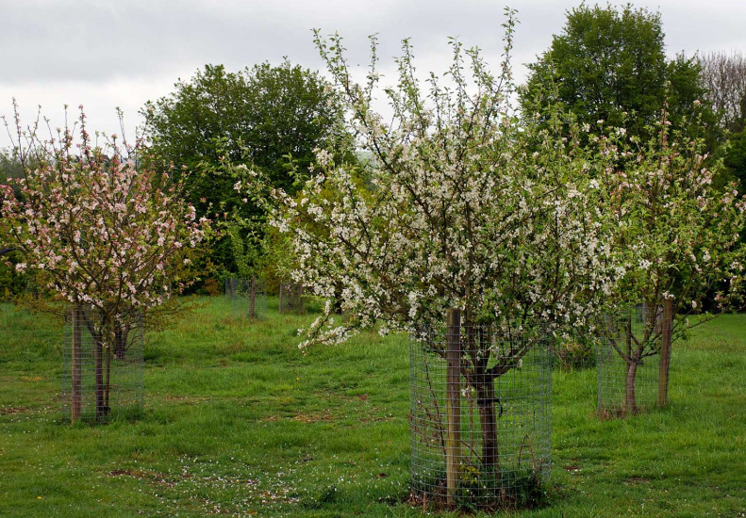

After the half term break the collective worship theme will be focused on the Christian value of ‘Justice.’ This does not just mean that all are equal but instead teaches how we can support those less fortunate than ourselves and how to support the oppressed.
“He has told you, O man, what is good; and what does the Lord require of you but to do justice, and to love kindness, and to walk humbly with your God?” (Micah 6:8).

