March 2023 Newsletter
Diary Dates

Tuesday 28.02.23, Wednesday, and Thursday, Year 4 parent consultations in the classroom

Wednesday 01.03.23 PTA meeting

Thursday 02.03.23 World Book Day with visiting author, please come dressed as a book character

Friday 03.03.23 Year 6 House Captains Cake Bake fundraising for Children against Cancer

Wednesday 08.03.23 Golf Day, for all classes – please wear PE kit all day

Monday and Tuesday, 13.02 and 14.02.23 – Science days with collapsed curriculum

Friday 31.03.23 Last Day of term –Isleham’s Got Talent

Monday 17.04.23 Staff Professional Development – NO CHILDREN IN SCHOOL

Tuesday 18.04.23 Children return to school for the Summer Term

Future dates for your diary

Friday 26.05.23 Last day of school before the half term, and sponsored ‘wheelathon’

Friday 30.06.23 Concert on the field followed by a gala – 2.30pm start

Message from the Head Teacher
Thank you to all parents and carers who were able to attend the parent consultation meetings; it was good to see so many of you finding out about your child’s education and how to support at home. Don’t forget that the school only ask you to regularly hear your child read, practise the spelling words each week and spend time with times tables recall, as home learning tasks.
Please remember that parking is not allowed on the zig zag lines, on either side of the road. We are still seeing some dangerous parking with cars going onto the pavement and also using the space that should be available for school access. Even dropping off your child quickly could cause an incident, so please give yourself a few more minutes to be safe. Thank you for your support with this matter, Dawn Deacon
Bring and Buy Sale
Please provide any unwanted items for the Year 6 house captain bring and buy sale.
Everything should be in good condition, either new, or in the original box and hardly used.
Possibly the following:
- Cuddly toys
- Games
- Colouring books
- Pens or pencils
- Notebooks or stationery items
Special Me, Special You, house day
Last week the school had a house day with a theme around resilience and facing challenge. This was to make the children more aware of disabilities, and also know that whatever life brings, you can always fight and try things in a different way – show resilience. Here are some of the Year 5 pieces that have been written about the day:
Yesterday, on Wednesday 22nd February 2023 it was our house day. The theme was,’ Special me, special you.’ Through the morning we were split into our house teams to do activities. Later, in the afternoon we had a motivational speaker called Darren Edwards come and talk to us. (Ellouise, Year 5)
We played sit down volleyball for people with no legs or people that cannot use their legs. You have to sit on your bottom to play. There were other tasks too, such as painting using your foot and writing names and other things in braille. We also experience sight challenges. (Laurence, Year 5)
We went to assembly and had a special visitor called Darren Edwards. He told us that he was an adventurer and that he fell down a mountain. His friend saved him but he had to have a wheelchair. He showed resilience and went on more adventures. He told us that after his accident he started kayaking and he went all the way from Cornwall to John O-Groats with his friends. He taught us that if you have a disability you can do anything. (Millie, Year 5)
Darren was super cool and inspiring. This just goes to show that even though everyone is different, we can all achieve greatness. (Ellouise, Year 5)
Golf Day
At Isleham C of E School the motto is to, ‘Let your light shine,’ but this does not always mean by being skilled in one area. The interpretation of the Christian motto, is to show your personality, try your best, be a good person and we enjoy providing the children with new experiences to shine

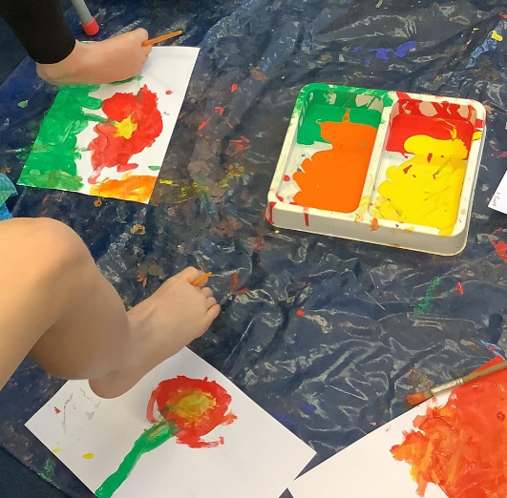
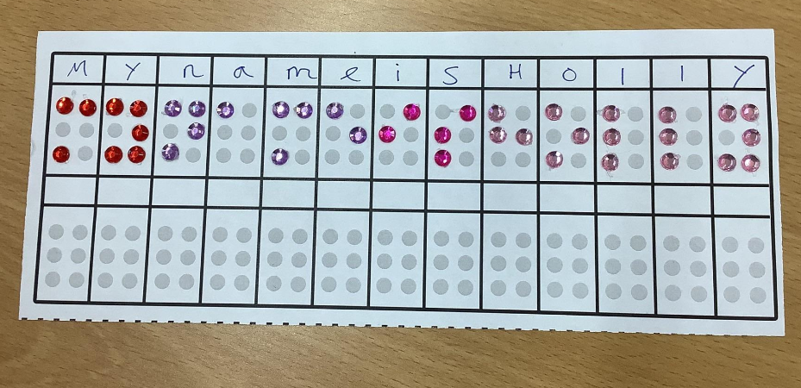
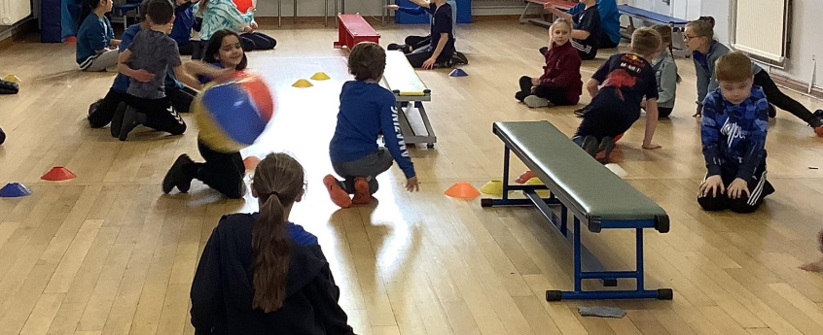

with. On the 8th March each member of the school will have the opportunity to try out golf. Over the day each class will receive instruction from a member of the Wichford sports partnership, and you never know if we will find the next Tiger Woods, or they might find a new hobby that they enjoy!
Recycling at its best!
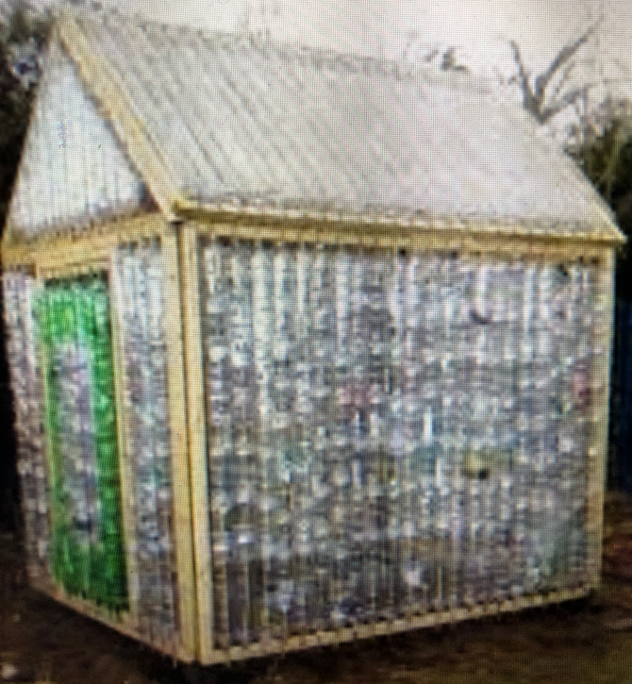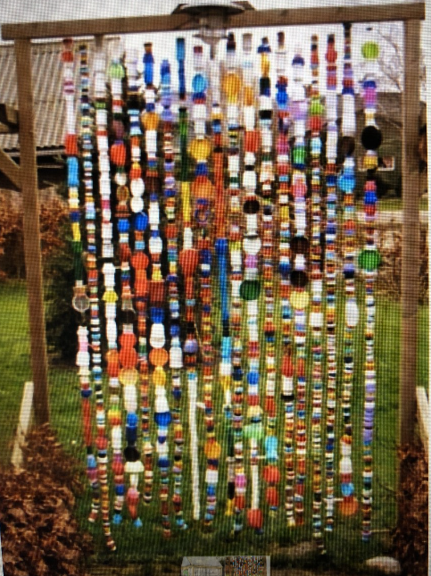
The final piece of the newsletter relates to an exciting outdoor project that is being organised by some of the TA’s alongside the Eco council members.
They would like you to bring into school any plastic bottle tops, of any size and colour, as well as empty 2 litre drink bottles. This is to create a decorated area (hanging plastic lid curtain) near the trees on the field, and also to make a greenhouse! Yes, you are reading correctly, a greenhouse made from used drink bottles!
There are other ideas being discussed to really excite and extend the space on the field. You will have to wait for more details in coming newsletters!

Cake Bake!
On Friday!
Please try to support the Year 6 house captain cake bake on Friday 3rd March 2023. Either donate cakes or biscuits on the day, or just turn up at the end of the school day with some money to purchase a cake. The children will be making some cakes over the afternoon and so you can taste their cake baking skills! All cakes will be 50p each, with cash only sales.

