March 2 2023 Newsletter
Diary Dates

Monday and Tuesday, 13.02 and 14.02.23 – Science days with collapsed curriculum

Friday 31.03.23 Last Day of term –Isleham’s Got Talent

Monday 17.04.23 Staff Professional Development – NO CHILDREN IN SCHOOL

Tuesday 18.04.23 Children return to school for the Summer Term

Future dates for your diary

Friday 26.05.23 Last day of school before the half term, and sponsored ‘wheelathon’

Friday 30.06.23 Concert on the field followed by a gala – 2.30pm start

Message from the Head Teacher
Once again the school have thrown themselves into new and exciting activities, including world book day, a golf session and a fantastic fundraiser by the Year 6 House Captains. We have said in the staff room, that it will be lovely to have the knowledge and comfort of a ‘usual’ week, but with a few days of science and then Isleham’s Got Talent, that is unlikely to be the case before the end of term! We wouldn’t have it any other way though, as these different activities allow the children to participate in a wealth of experiences and to ‘Let their light shine.’
This year we have decided to support ‘Red Nose Day,’ with allowing the children to wear any merchandise but not ask for any money. As we have just raised money for a charity close to our hearts, so we felt that we could not ask for more from you. Please feel free to donate to the day via online or text message versions, if you so choose but the children are welcome to be wearing red nose t shirts, head bands and of courses the nose.
With regards Dawn Deacon

We are very excited to inform you that the cake bake sale, organised, prepared and executed by the Year 6 house captains, raised an absolutely fantastic amount of £200 towards the charity! What courageous advocates we have in school and I am very proud of the team!

Golf Day Photographs
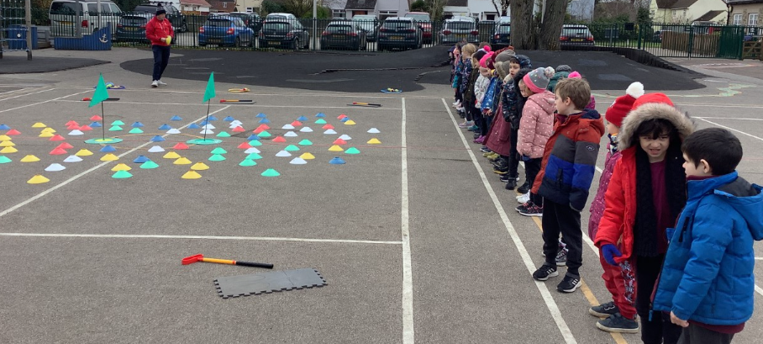
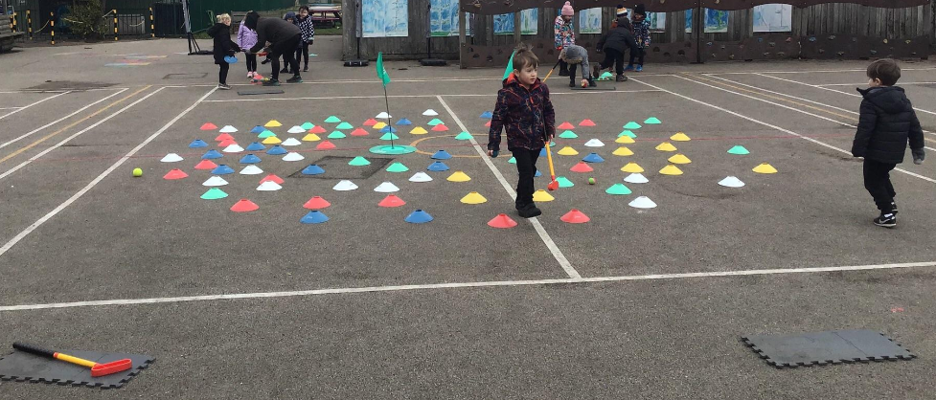
World Book Day Photographs – with some amazing costumes!
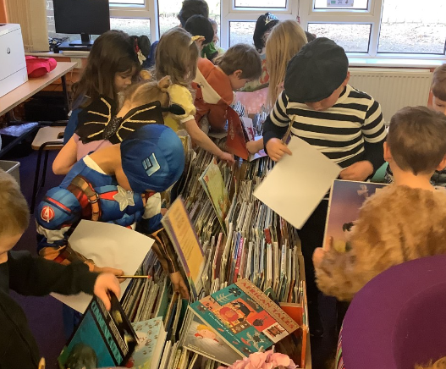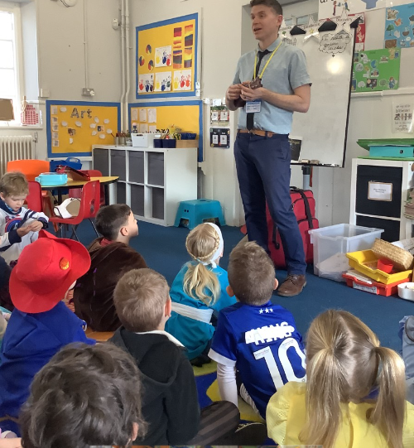
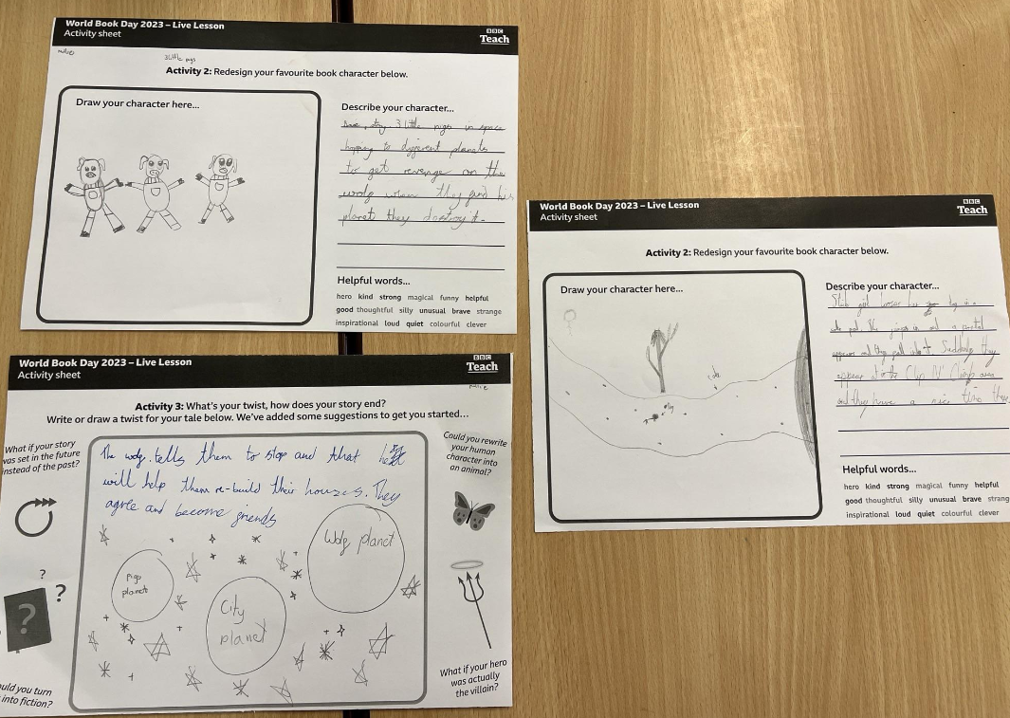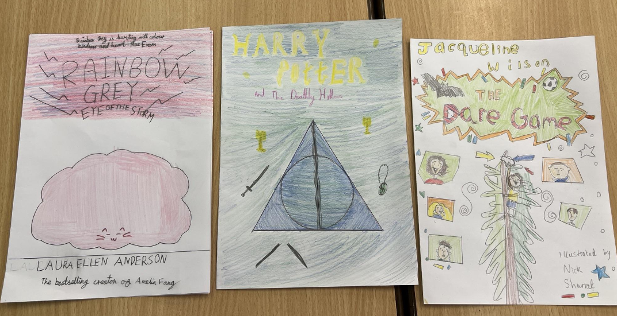

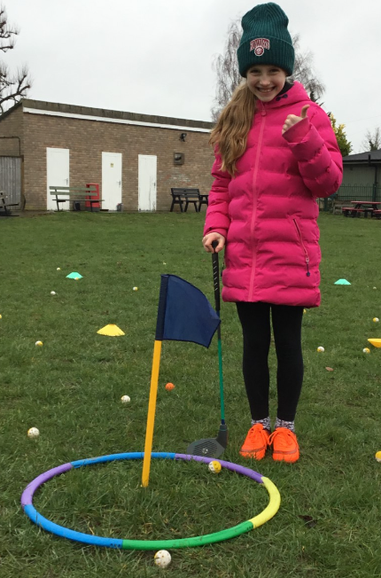
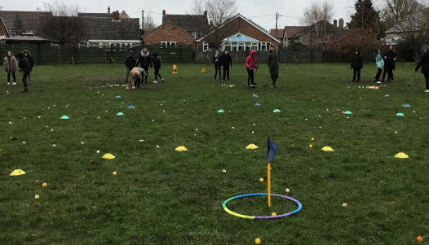
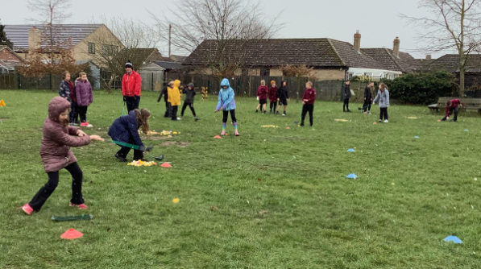
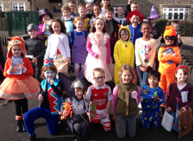
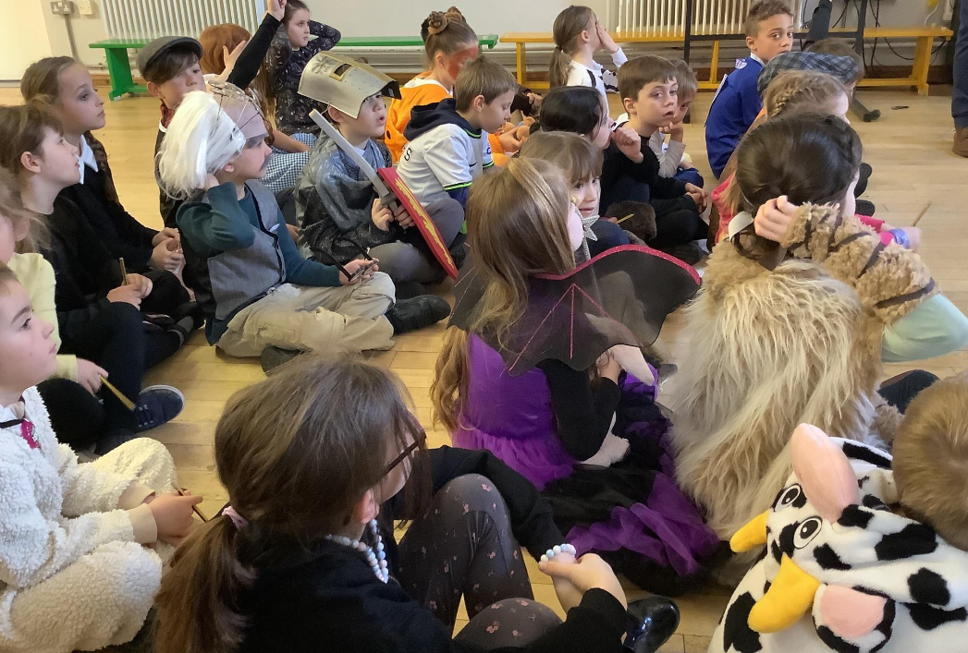
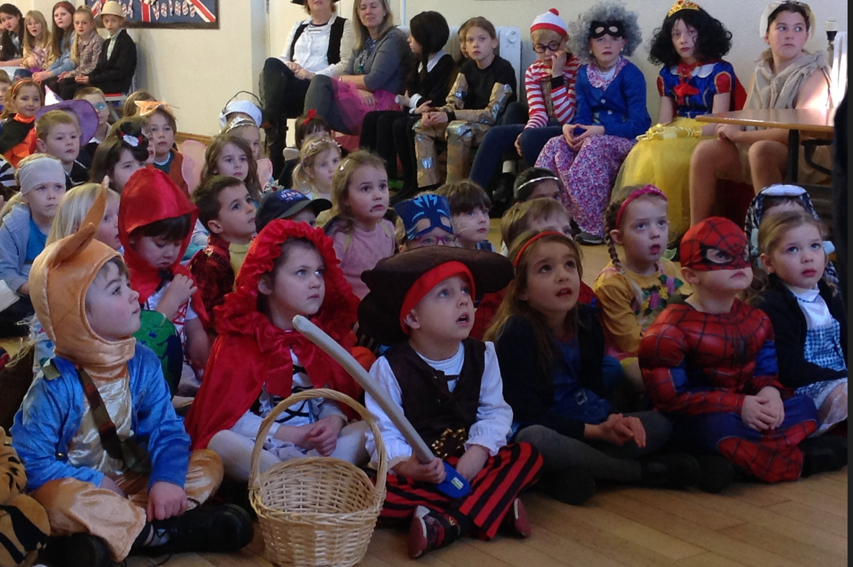
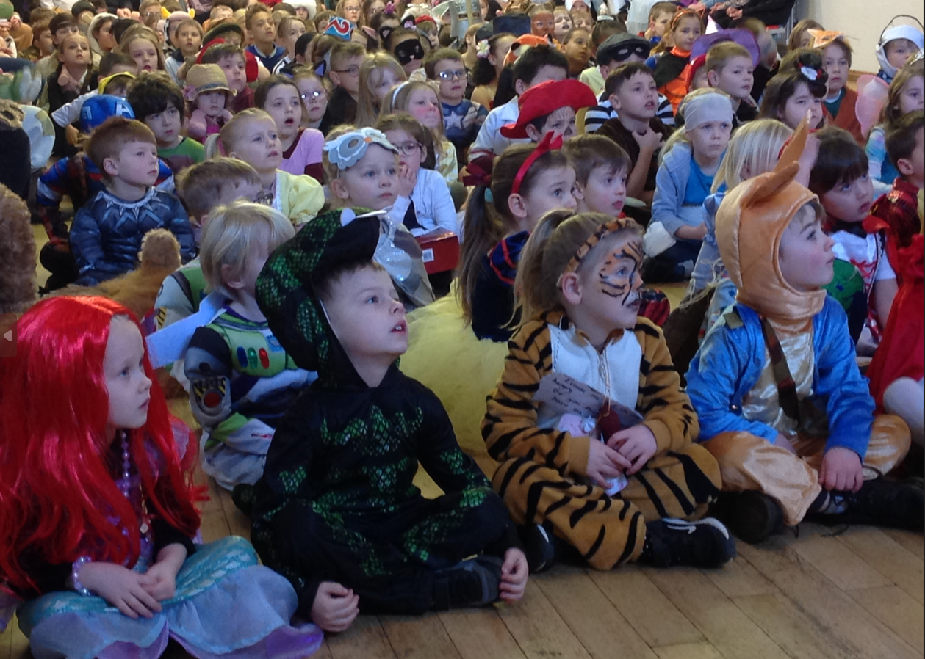
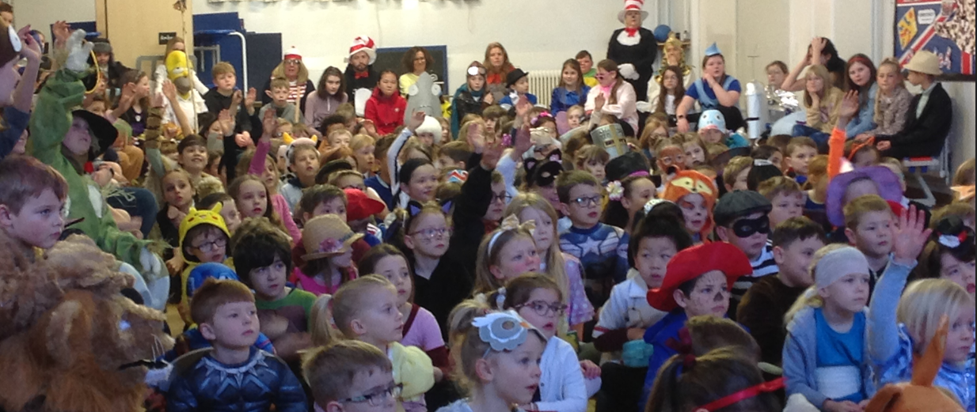

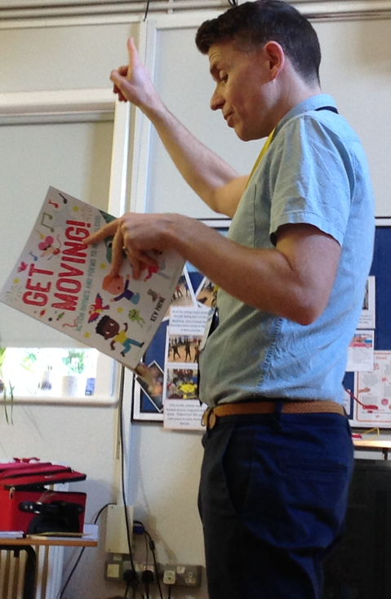

The visiting author, Kev Payne, was engaging and interesting for both the assembly session and also in the individual class time. He brought his rhymes to life with the use of a ukulele, actions and song!
Throughout the day there were lots of book activities and even the Pre-School had book character visits while they used our library!

Recycling
Please can I remind you all that we have the capacity to recycle the following items at school:
- Batteries
- Crisp packets
- Ground coffee packets
And we are also requesting any plastic bottle tops and 2 litre plastic bottles, for building a greenhouse!

Pantomime
Some of the pupils (and our very own caretaker, Mr Drayton) from Isleham Primary School will be taking part in the production. I believe that the matinee show is sold out, but there are still tickets available for the Friday and Saturday nights.
If the previous pantomimes are any measure, then you are surely in a for fun production!

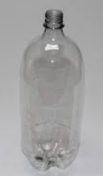

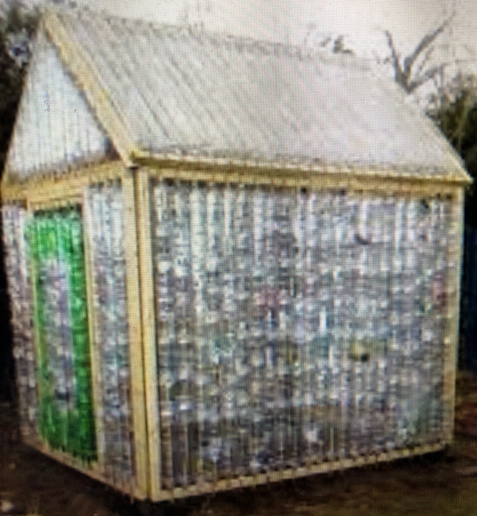
We would like to build one (or two) of these to grow vegetables. We will need lots of plastic bottles!

And the barked area on the field will be decorated with something like this:

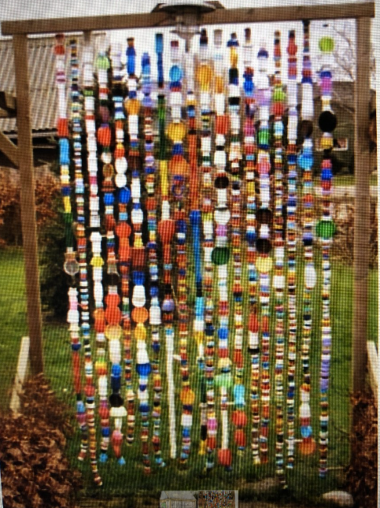
Again, lots of different bottle tops are needed before it can be made up.

